Tasker Manual

INTEG Process Group, Inc.
2919 East Hardies Rd, First Floor
Gibsonia, PA 15044

PH (724) 933 - 9350
FAX (724) 443 - 3553

www.integpg.com
support@integpg.com
sales@integpg.com

© 2021 INTEG Process Group, Inc.
All Rights Reserved

Last updated on: May 4, 2021

Table of Contents
Drop-Downs 2
File Drop-Down 3
Tools Drop-Down 4
Help Drop-Down 4
Workspace Tabs 5
Task Tab 5
Actions 6
Interprocess Actions 6
Network Actions 7
Logging Actions 8
Lighting Actions 8
Control Panel Actions 9
Analog Output Actions 9
Digital Input Actions 10
Control Structure Actions 12
Timing Actions 12
Other Actions 13
File Actions 14
Device Tab 14
Signal Tab 15
Trigger Tab 15
Schedule Tab 17
Schedule Rules 18

Introduction
The purpose of the Tasker application is to function as the Series 4 version of the Task Manager application. This application can be used to set up tasks that you wish to occur on the JNIOR. These tasks can perform many actions, such as controlling outputs, expansion modules, logging information, sending emails, etc. These tasks can be set on timers at different intervals, be connected to different external devices, or be determined by certain triggers as well.

Drop-Downs
The Drop-downs are there for directing the User to help load or create workspaces, access other applications, and get application information.

File Drop-Down
The File Drop-Down has many option, which all pertain to either Loading, Editing, Creating, and Deleting workspaces.

- A workspace is a way to make a specific configuration of tasks that you’ve created, so that you may load it at a later time if you need to.

- The New Option is used to create a blank workspace to the application.
- The Open Option will load a previously made workspace into the application.
- The Save Option saves the current configuration with the name it currently has and where its already saved to.
- The Save As Option saves the current configuration with the name you define before selecting where it saves to.
- The Close Option exits the current workspace and lets you view the list of avaiable ones to open.
- The Revert Option loads the last previously saved version of a workspace.
- The Samples Option allows you to open premade workspaces to use.
- The Enable/Disable Option allows you to stop or start a workspace from activating tasks.
- The Delete Option removes a workspace that was saved.
- The Upload Option lets you load a workspace you have saved on your computer in Tasker.
- The Download Option lets you save a workspace from Tasker to your computer.
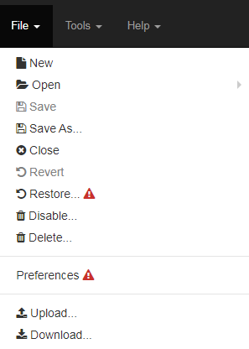

Tools Drop-Down
The Tools Drop-Down provides links to different web pages.

- The Grapher application can be used to take data and make viewable in a real time graph.
- The Grapher configuration page is where the options are located to alter and configure the Grapher application.
- The DCP is used to interact with the JNIOR in multiple ways, such as its I/O, Logs, Command Line, Registry, etc. Summary

Help Drop-Down
The Help Drop-Down provides links, similar to the Tools tab, but these links are there to help accessing other sites or pages that will help explain the tasker application.
- A link to the help web page of the Tasker application, this explains all the actions in more detail, in case the actions need more explanation then what is shown in this manual.
- A link to the Knowledge base, which is on INTEG’s website. Here there is a collection of posts that explain how to setup different configurations in Tasker that could match or do something possibly similar to what someone is trying to accomplish in Tasker.
- A link to the Contact Us page on INTEG’s website. If there any questions that aren’t answered here, this page lets you send an email or join a support chat with someone from the INTEG support team.
- A link to the Tasker application on INTEG’s website. In case you need to re-download or update the current version of Tasker, a link to the application on our website is here.
- A display showing the current version of the Tasker application, and the Tasker web page. These are useful to view to make sure the most recent version of Tasker is on your JNIOR.

Workspace Tabs
The Workspace Tabs allow for the creation or configuration of tasks in Tasker. As of 6.0 Workspaces will warn you if your configuration is out of date on the webpage, and ask you reboot.

Task Tab
The purpose of the Tasker application is to function as the Series 4 version of the Task Manager.

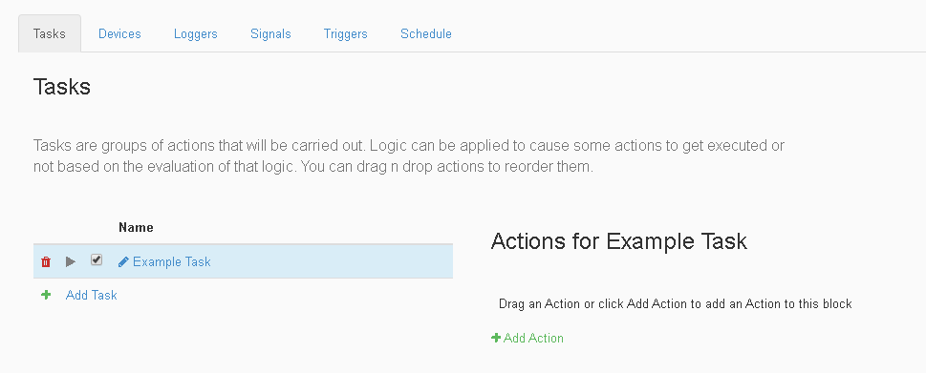

- The task section is where you can add, remove, and edit tasks.
- The Trashcan icon is used to remove unwanted tasks from the tasker application.
- The Pencil icon is used to rename a task.
- The Play icon is used to run a task.
- The Checkbox icon is used to set if a task is enabled or not.
- The Add Test button adds a new task after it is named.
- Clicking on the task name brings up all the actions the task performs.

Task Actions
Actions are the commands that you can add to tasks.
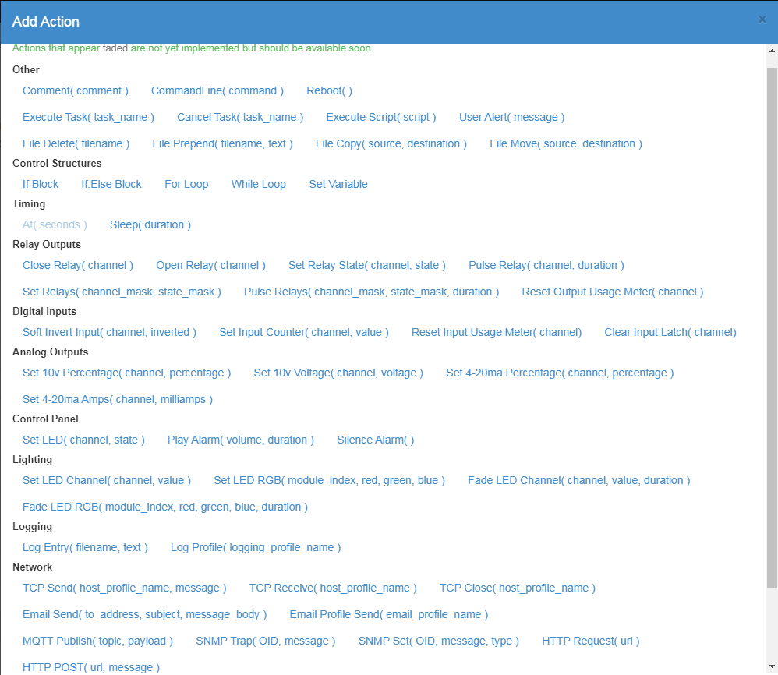

Interprocess actions
- allow interaction with a different applications, such as DMX, Cinema, or the Message Pump
Waiting for functionality

Network actions
- allow sending information over email, SNMP, HTTP, MQTT, and TCP.

Email
The Email Send action allows the entry of the Email Address the message is being sent to in the first text field, the subject of the message in the second text field, and message of the email in the text body field.

The Email Profile Send action allows the entry of an Email Profile that you have configured for you JNIOR device to activate.

TCP
The TCP Send action lets you select a device from the device tab and send it data you enter through TCP.

The TCP Receive action lets you select a device from the device tab to receive data from.

The TCP Close action closes a TCP connection made with another device.

SNMP
The SNMP Trap action lets you use a SNMP device from the Device tab to send data to a create a SNMP Trap.

The SNMP Set action lets you set the a defined SNMP value for a device.

HTTP
The HTTP Post action lets you post a message on a defined JNIOR’s message pump.

The HTTP Request action lets you perform a HTTP Request method on a specified URL.

MQTT
The MQTT Publish action let you publish a value on the specified topic to a MQTT broker when using the MQTT application with it.

Logging actions
- allow logging of information about your tasks.

The Log Entry action allow text entered in the first text field to be logged into the file name of second text field.

The Log Profile action triggers the Log Profile entered into the text field.

Lighting actions
- allow control of LEDs for outputs on the JNIOR along with the color of the LED 3 Channel Dimmer.

Set Channel
The Set LED Channel action sets 1 of the 3 Dimmer Channels to a percent of 0% - 100%.

The Set LED RGB action sets all 3 of the Dimmer Channels each to a percent of 0% - 100%.

Fade Channel
The Fade LED Channel action sets 1 of the 3 Dimmer Channels to a percent of 0% - 100% and can set the time in seconds it takes to fade into the channel percentage.

The Fade LED RGB action sets all 3 of the Dimmer Channels each to a percent of 0% - 100% and can set the time in seconds it takes to fade into the channel percentage.
Control Panel actions
- allow the control of the functionality of the control panel expansion module.

LED
The Set LED action allows you to set the states of the LED light to any of the 8 switch options on the control panel, with the state options being off, slow, medium, high, on.

Alarm
The Play Alarm action activates the alarm on the control panel, which allows you to control how loud the alarm is as a percent from 0% - 100% and the duration in seconds.

The Silence Alarm action turns off the alarm if it is currently running.
Analog Output actions
- allow control of the 10volt and 4-20ma expansion modules and their outputs in percentage and power.

10volt Analog
The Set 10v Percentage action allows one of two channels on the 10v Module to be set as a percentage from 0% - 100%.

The Set 10v Voltage action allows one of two channels on the 10v Module to be set as a voltage number between 1 - 10.

4-20ma Analog
The Set 4-20ma Percentage action allows one of two channels on the 4-20ma Module to be set as a percentage from 0% - 100%.

The Set 4-20ma Amps action allows one of two channels on the 10v Module to be set as milliamps from 4 - 20.

Digital Input actions
- allow control over input inversion, counter reset, and usage reset.

The Soft Invert Input action allows you to enter the input channel number and if its should invert or not.

The Set Input Counter action allows you to set the counter number for any input you enter.

The Reset Usage Input Meter action allows you to reset the usage meter of whatever input channel you enter.

The Clear Latch Input action allows you to reset a latch set for an input.

Relay Output actions
- allow control over setting and pulsing outputs, either by masking or channel.

The Close Relay action allows you to close the output channel of the channel number you select.

The Open Relay action allows you to open the output channel of the channel number you select.

The Pulse Relay action allows you to pulse the output channel of the channel number you select for the time duration you select.

The Set Relay action allows the you to control weather a certain output channel is high or low.

The Set Relays actions allows you to enter the mask of the channels to select which channels you want to change, and the state mask, which is 1 for closed, and 0 for open.

The Pulse Relays actions allows you to enter the mask of the channels to select which channels you want to change, the state mask which is 1 for closed, and 0 for open, and the time duration the pulse should last.

The Reset Output Usage Meter action allows you to reset the usage meter of a output channel.

Control Structure actions
- allow logic to be implemented into tasks, such as loops and if statements.

Loops
The For Loop action allows you to first enter the name of the loop you wish to create, and then enter the number range you wish the loop to go through
(EX. would be 1 - 10 or 10 - 1).

The While Loop action allows you to reiterate some actions for an indefinite amount of time until the condition for the while loop is met.

If Blocks
The If Block action allows you to enter a condition in its field, and will execute action inside it once the condition has been met. (EX. {{din[1].state}} == 1 would make it so that when input one is on, the actions in the If Statement will trigger.)

The If Else Block action allows one set of actions to occur if the condition of the If Else Block is met, and another set of actions if the condition is not met.

The Set Variable action lets you create a variable, setting its name and then the value its equivalent to.

Timing actions
- delay commands in units of seconds and milliseconds.

The Sleep action requires the unit of time in milliseconds, seconds, or minutes, then the numeric amount of time you want the application to wait.

Other actions
- provide other functionality to tasks such as command line commands, comments, and rebooting.

The Comment action will allow text entered in the text field to be logged.

The Command Line action allows you to enter text into the text field to activate a command line action on the JNIOR.

The Reboot action will activate a reboot on the JNIOR (This should be the last action in the task or the tasks after it will not run).

The Execute Task action lets you enter a Task that is already created and activate within another.

The Cancel Task action lets you end an active task that you specify.

The Execute Script action allows space for functions to be called or values to be set within a task.

The User Alert action displays the message you enter as an alert to the user on the web page.

File actions

The Delete File action lets you enter the name of a file on the JNIOR delete it.

The Prepend File action lets you enter the name of a file on the JNIOR and some text. It then adds that to text to the front of the file.

The Copy File action lets you enter the name of a file and a folder address on the JNIOR. It then copies that file to the folder address.

The Move File action lets you enter the name of a file and a folder address on the JNIOR. It then moves that file to the new folder address.

Device Tab
The Device Tab allows you to set a type of Device to communicate through different task actions.

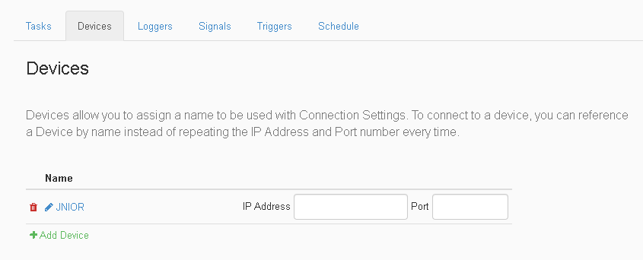

- The Red Trashcan icon is used to remove unwanted Devices from the device tab.
- The Pencil icon is used to rename the created Device.
- The Add Device button adds a new task after it is named.
- The IP Address text field defines the IP of the device.
- The Port text filed defines the port of the device.

Signals Tab
The Signals Tab allows you to interact with the I/O of either Expansion Modules of a JNIOR or the JNIOR I/O itself.

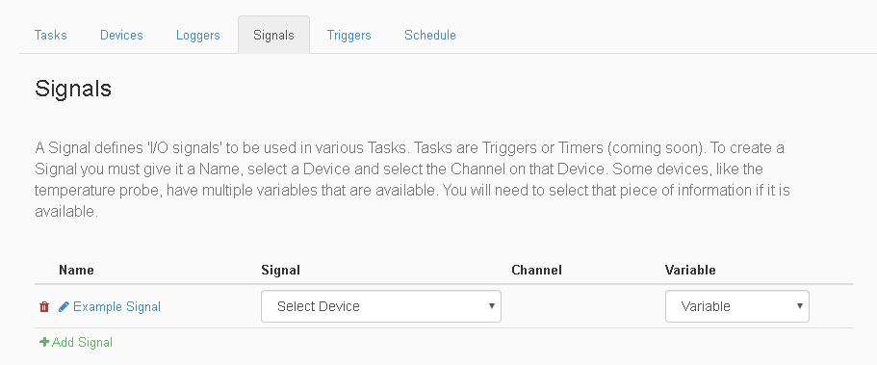

- The Red Trashcan icon is used to remove unwanted Signals from the Signal tab.
- The Name field is the name you give to the Signal.
- The Signal field is a drop down that lets you select from a list of all possible I/O options either on expansion modules or build into the JNIOR itself.
- The Channel field lets you select an I/O from the available ones selected in the Signal field.
- The Value field can select a value for the channel of the chosen Channel. This will also change depending on the Signal picked.
- The Add Signal option lets you add another Signal in the Signal Tab.

Trigger Tab
The Signals Tab allows you to interact with the I/O of either Expansion Modules of a JNIOR or the JNIOR I/O itself.

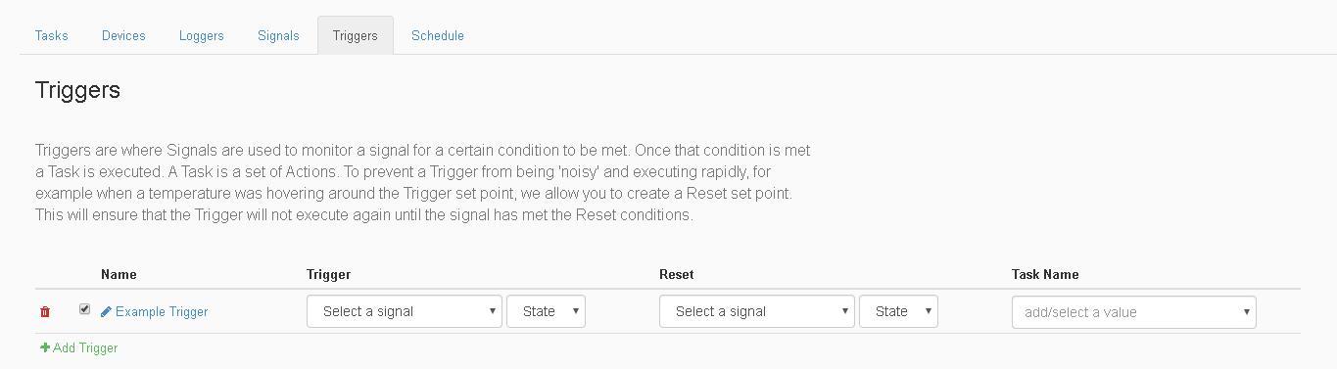

- The Red Trashcan icon is used to remove unwanted Trigger from the Signal tab.
- The Checkbox icon is used to either enable or disable if the Trigger is active.
- The Name field is the name you give to the Signal.
- The Add Trigger option lets you add a trigger to the page. There are for types of Triggers. The discrete signal is a value such as an input or output on the JNIOR, the continuous signal is a value such as a constant reading from a temperature sensor, the control panel switch value is a button press on the control panel, and the multi panel switch value is two button presses occurring at the same time on the control panel.
- The Trigger field is a drop down that lets you select from a list of all possible Signal options created in the Signal Tab. This will be the Signal will determine if activate a trigger. There is also a drop down for what the value the Signal needs to be
- The add Reset button adds a reset to the trigger. This makes it so that once the Trigger activates, it won’t re-activate until the reset condition has occurred. It has the same value options as when adding a Trigger, but it also contains a delayed timer value, which just sets a time in seconds until the Trigger can activate again.
- The Tasker field is where you select the task you wish to run when the trigger is activated.

Schedule Tab
The Schedule Tab allows you to create rules that will set a time for when specific task you select should run.

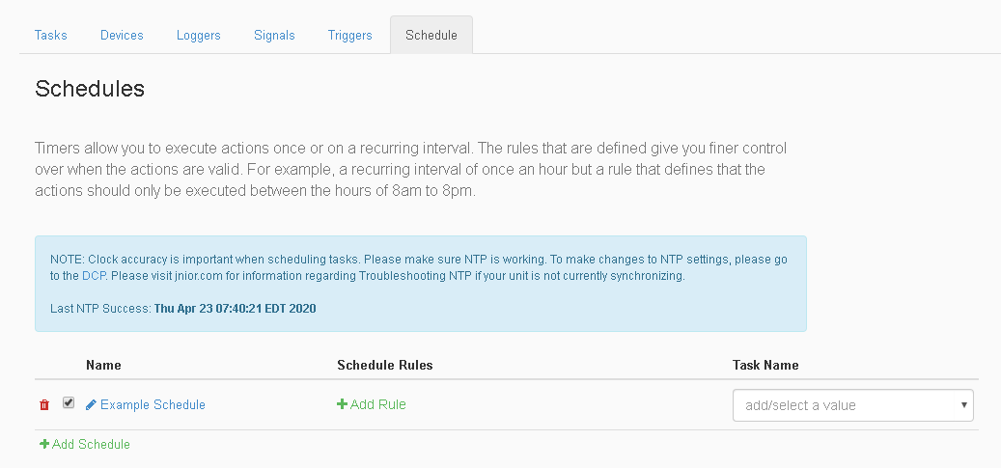

- The Red Trashcan icon is used to remove unwanted Devices from the device tab.
- The Pencil icon is used to rename the created Schedule.
- The Add Schedule button adds a new schedule after its named.
- The Add Rule button brings up the Schedule Rule dialog box to add rule conditions to a Schedule.
- The Task Name text field is where the Task that should be activated during the schedule is typed.

Rules
Rules are settings for the Schedule you create.
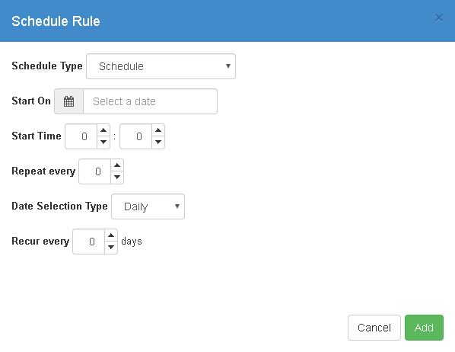
Schedule Type
The Schedule Type can be either Schedule, On boot, Sunrise, Sunset. On boot will run the task every time a reboot occurs. Sunrise and Sunset will run the task at Sunrise or Sunset for that day depending on which one is picked. Schedule allows additional options for a more customizable Schedule.

Start On
The Start On option selects the date when the task will begin to run on a schedule. You first select the Year and the Month in which the task should happen, followed by the day of that Month.

Start Time
The Start Time option allows the task to be scheduled on a 24 hour time frame, down to the minute. An example is if you wanted to enter 5:30pm, you’d enter 17:30 since it goes by hours and then minutes.

Repeat Every Option
The Repeat Every option turns the Schedule from running once a day to running a number of times equal to what you set. It also adds an endtime to set a time interval between the start and end time. It will repeat the set number of times inside that time interval. The end time is also hour based and down to the minute as well, similar to the Start Time option.

Date Selection Type
The Date Selection Type allows the selection of days the task can run. Selecting Daily will make the Recur Every Option let you pick based off how many days between repeating the task. Selecting Weekly will make the Recur Every Option let you pick the days out of the week you wish to repeat the task. Selecting Monthly makes the Recur Every Option let you to pick the days out of the month you wish to repeat the task. The One Time option makes it so that the Schedule will run one time only.

Recur Every Option
The Recur Every Option allows you to select which days the Schedule will run, and changes according to the Date Selection Type chose. It can be either, a one time event, between a certain amount of days, certain days in a week, or certain days in a month.

Summary

Thank you for purchasing the JNIOR. Hopefully this manual made the getting-to-know process of your new JNIOR very quick and easy. The JNIOR has many more wonderful tools and features available, and are explained in detail in the supplied documents.

Copyright Copyright  2021 INTEG Process Group, Inc.
All rights reserved.

Notice Every effort was made to make this manual as accurate and useful as practical at the time of the writing of this manual. However, all information is subject to change.

Trademarks Trademarks are the property of their respective holders.
Sun, Sun Microsystems, the Sun logo and Java are trademarks or registered trademarks of Sun Microsystems, Inc. in the United States and other countries.
Microsoft, Windows, MS-DOS and Internet Explorer are registered trademarks of Microsoft Corporation.

Use Restrictions This User’s Manual and the software contained in the JNIOR are copyrighted by INTEG Process group and may not be copied or reproduced without prior consent from INTEG Process Group, Inc. INTEG Process Group is not responsible for any errors or omissions that may be contained in this manual.

Please do not hesitate to contact our JNIOR team at INTEG Process Group, Inc. We can be reached via phone, fax or e-mail as follows:

INTEG Process Group, Inc.
2919 East Hardies Road, First Floor
Gibsonia, PA 15044

www.integpg.com
sales@integpg.com
support@integpg.com

PH (724) 933-9350
FAX (724) 443-3553

