JNIOR Series 3
A Network I/O Resource
Utilizing the JAVA™ Platform

Task Manager Manual
Release 4.0

Disclaimer: Task Manager has been replaced by the Tasker Application on the series 4 JNIOR. You can continue using Task Manager but new implementations on the Series 4 JNIOR should use the new Tasker Application.

NOTE: JNIOR OS 3.4 or greater required

Last updated on: July 28, 2009
TABLE OF CONTENTS

1 What is the Task Manager? 3
2 The Purpose of the Task Manager 3
3 Guidelines on Using the Task Manager 3
4 Enabling the Task Manager Software 4
5 Configuring Task Manager 5
5.1 Stopping the Task Manager 7
5.2 Tasks 7
5.2.1 Creating a New Task 7
5.2.2 Today’s Tasks 8
5.2.3 Tasks Execution Timing 8
5.2.4 Types of Tasks 9
5.2.5 Editing an Existing Task 16
5.2.6 Removing a Task 16
5.2.7 Duplicating a Task 16
5.2.8 Running a New or Changed Task 16
5.3 Actions 17
5.3.1 Adding an Action 18
5.3.2 Editing an Action 22
5.3.3 Removing an Action 22
5.4 Saving Your Changes 22

What is the Task Manager?

Task Manager is a software application included on each JNIOR that provides the user with a simple way to control outputs on the JNIOR, log information and send e-mail notifications based on a specific day and time and/or based on an event (input triggered, analog value exceeded, etc.). A user-friendly Web page allows you to configure the various ‘tasks’ and ‘actions’ for your JNIOR.

The Purpose of the Task Manager

The Task Manager program that runs on the JNIOR is meant to be a control and condition monitoring solution. It is not a complete logic controller, but rather a way to have some control over the JNIOR without having to write a program on a separate computer. Tasks can be scheduled based on time or events to control outputs, log data, clear counters or usage meters, send e-mail and a variety of other actions. The variables to be logged can be easily chosen so that after you extract the file from the JNIOR, the data can be easily manipulated and viewed.

Guidelines on Using the Task Manager

The Task Manager is used to configure a variety of Tasks with each Task containing one or several Actions. Each Task is triggered based on a ‘time’ or an ‘event’.

The time-based Tasks can be scheduled any time of the day or week and the Task Manager checks for Tasks to occur on a fixed interval of time that is approximately once every five seconds. This means that if a Task is scheduled to occur at 8 am, then the Task can have a start tolerance between -0 seconds and +5 seconds or between 8:00:00am and 8:00:05am.

The event-based Tasks are checked by the Task Manager on a fixed interval that is approximately once every 200 milliseconds. The JNIOR has a software configurable de-bounce feature on the inputs with a default setting of 200 milliseconds. If the de-bounce setting is set below 200 milliseconds, it is possible to miss a transition of an input if a pulse occurs that is too fast for the Task Manager to detect. This can be overcome by using the input latch feature. For the outputs, care must be taken in scheduling a pulse of less than 500 milliseconds in duration.

The JNIOR does not have a large hard disk or unlimited memory. Making effective use of log files is essential. All log files must be stored in RAM. This means any location EXCEPT the Flash folder. The Flash folder is to be used only to hold programs and configuration items that will remain in flash memory even if the battery fails. Use the max file size function in the Task Manager to make sure you do not fill up the JNIOR RAM which can lead to unexpected results. The max file size should be a value that you do not intend on reaching. Please make it a point to clean up files by using FTP to extract them from the JNIOR and then deleting them on the JNIOR. The total RAM memory available for storing data on the JNIOR is approximately 1 MB. This equates to approximately 30,000 data points with a date and time stamp each. When the JNIOR reaches the maximum file size configured for the log, the JNIOR will create a *.bak file that is a back-up of your data and then start a new file. When this file reaches the target file size, it will overwrite the *.bak file and create a new file. Care must be used in selecting the file size for your logs since there may be 2 of each log file (the main file and the *.bak file) at some point in time.

Enabling the Task Manager Software

All JNIORs are shipped with the Task Manager software installed, but not running. Task Manager can be configured to run on boot via the main JNIOR web page. On the main JNIOR web page, go to the Applications tab, check the Task Manager box and click on the Save button. You will be asked if you want to reboot the JNIOR. Please select yes. Task Manager will now be running after the reboot and will be set to always run on boot. You can disable Task Manager by un-checking the Task Manager box and rebooting.

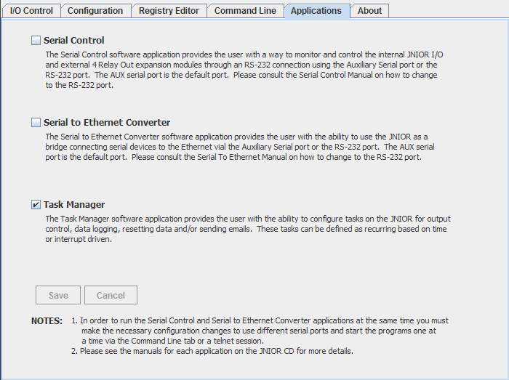

Configuring Task Manager

In order to configure Task Manager, the user needs to understand the difference between a Task and an Action. Task Manager can handle a variety of Tasks. Each Task is triggered based on a ‘time’ or an ‘event’. Each Task contains one or several Actions. When the Task is triggered, all the Actions in a Task will be executed in the order the Actions are listed. An Action can control an output (digital and analog), reset a counter or usage meter, log data or send an e-mail.

Task Manager is configured via the Task Manager Web Interface. The web interface makes it simple to Add, Remove, or Edit a Task or Action. Each Task can have multiple Actions associated with it. To launch the Task Manager Web Interface, type the IP address of your JNIOR followed by a slash and task.html in your Web browser address line. An example is as follows: http://10.0.0.208/task.html

When you launch the Task Manager Web Interface, you may be asked to log in. This will depend upon if you have configured your main JNIOR web page for automatic (Autonomous) log in or not. If you have to log in, please use the default JNIOR username (jnior) and password (jnior) or one that you have created.

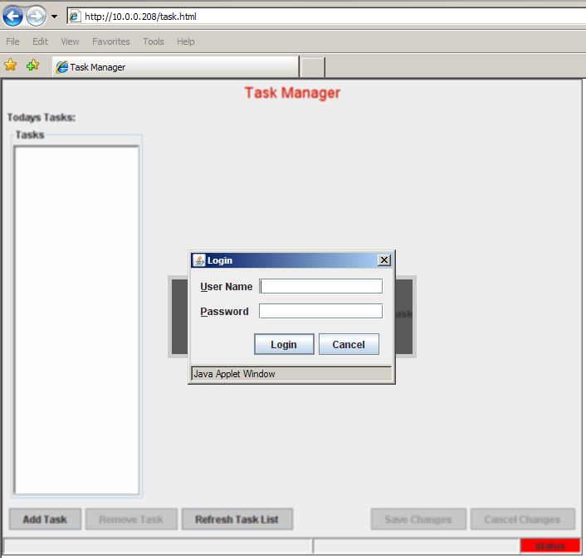

When the Task Manager Web Interface has loaded, two version numbers will be displayed in lower right corner. The ‘web’ version number is for the Task Manager Web Interface Java applet and the ‘jnior’ version number is for the Task Manager program running inside the JNIOR. The ‘status’ box will flash between green and white indicating the JNIOR side application is running and your Tasks will execute.

The first step you will have to do is to click on the Add Task button on the bottom left and then enter a name for your Task. The Task name will be displayed in the left window box. Click on your Task Name and the Task Configuration window will be displayed.

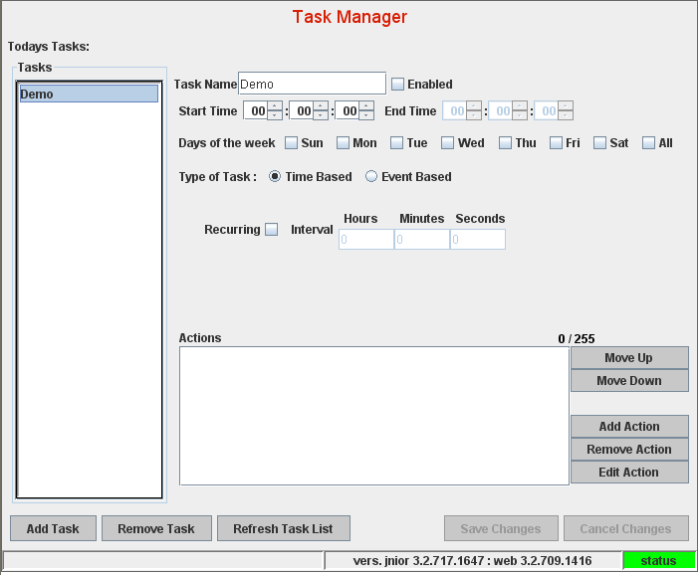
Make sure you Enable the Task

The various areas of the Task Manager web page will be described in the following.

Stopping the Task Manager

The Status box in the lower right corner of the web screen indicates if the Task Manager programming is running or not. If the program on the JNIOR is stopped, the box will be red and if the program is running, the box will flash between green and white. If you want to temporarily stop Task Manager, you can ‘right click’ on the Status box and then click on ‘STOP the Application’. This will stop the Task Manager program on the JNIOR until you reboot the JNIOR. If you want to stop Task Manager for a longer period of time, you can go to the main JNIOR web page and then the Applications tab. ‘Uncheck’ the Task Manager checkbox, click Save and then click yes to reboot. This will disable Task Manager from starting on reboot.
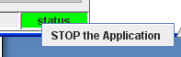

Note:
If you need to make many changes to the Task Manager at one time, then it is better to STOP the Task Manager first. After all the changes have been made, then you can reboot the JNIOR to start Task Manager again. However, you can elect to make all the changes while the Task Manager is running, but it may temporarily slow down the performance of the JNIOR.

Tasks

Tasks are the high level event in Task Manager that decides when the list of Actions associated with a specific Task will be executed. You can have a large number of Tasks and each Task can be enabled or disabled as to whether it is operational or not. A Task can be time based or event based.

Creating a New Task

To create a new Task click on the ‘Add Task’ button in the lower left corner of the web interface. When the box pops up asking you for the name of the Task, input a name without spaces.

Note:
The new Task is not saved until you edit one or more fields and click the Save Changes button. If this is not done then the Task will not be saved and the next time you visit this web screen you will not see the Task you just created.

Click on the Task you just made after the Task has been created and placed in the list box on the left. Edit boxes will appear for options.

Today’s Tasks

The Tasks that are currently enabled and marked to run on the current day of the week will be listed next to “Today’s Tasks”. It does not mean that they are currently running, but rather that sometime during the current day (24 hour period from midnight to midnight) they will be executed.

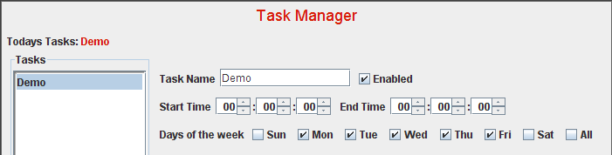

Note:
The schedule of Tasks for the 24 hour period gets reloaded every night at midnight. New Tasks or Actions can be added during the day and will cause the schedule to be reloaded and new Tasks/Actions will be executed if required.

The Tasks you have created will be listed in the box on the left. Clicking on anyone of them will load their information into the main box.

The Enabled checkbox is used to enable a task for execution.

Tasks Execution Timing

Tasks that are enabled will run depending upon the Start Time, End Time and Days of the week that are selected and the Type of Task. The start and end times are entered on a 24 hour basis starting at midnight (00:00:00). If the Task is going to execute once in 24 hours, then you only need a Start Time and the End Time is not active. If the Task is going to execute on a recurring time basis or based on an event, then you will need a Start Time and an End Time and so the End Time will be enabled. A Task can run on any specific day of the week or be set to run on all the days of the week.

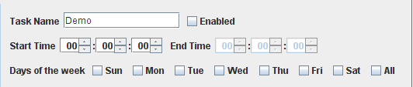

Types of Tasks

There are two types of Tasks. There are ‘time-based’ Tasks and ‘event-based’ Tasks.

Time-based Tasks are tasks that trigger based on a specific time of day. A time-based task will trigger only once at the start time.

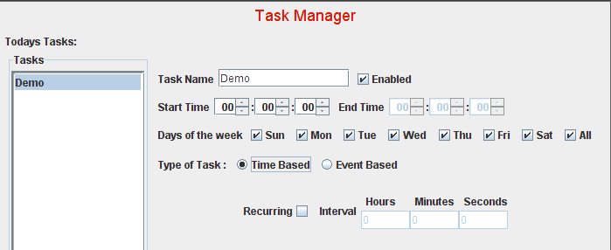

A time-based Task can also be set to execute on a recurring interval. When the Recurring box is checked, the End Time will become active. The user must also select the recurring time interval for repeating the Task.

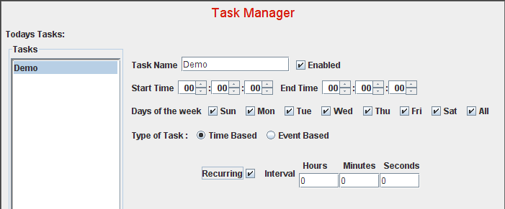

Event-based Tasks trigger off of several types of events that are based on the status of the JNIOR core digital I/O or any of the expansion module I/O available for the JNIOR.

JNIOR Digital Input Event

An event can be triggered based on changes in the JNIOR 310 digital inputs, including a transition (change in I/O state), a counter value reaching a set point, or a usage meter reaching a set point.

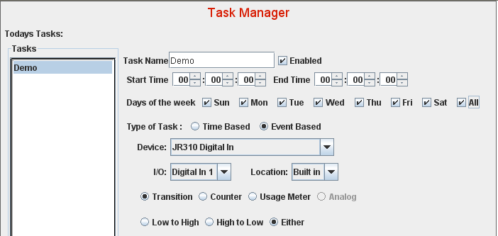

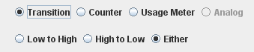
Input Transition – when input state changes from low to high, high to low, or either

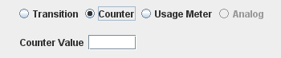
Counter Value – enter a whole number and the event will be triggered when this value is reached (equal to).

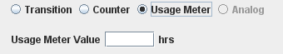
Usage Meter – enter a value with decimal places and the event will be triggered when this value is reached (equal to).

JNIOR Digital Output Event

An event can be triggered based on changes in the JNIOR 310 digital outputs, including a transition (change in I/O state), or a usage meter reaching a set point.

JNIOR 310 Internal Relay Outputs – monitors the state of the eight (8) internal relay outputs when the output state changes from low to high, high to low, or either; or when a usage meter value is reached.

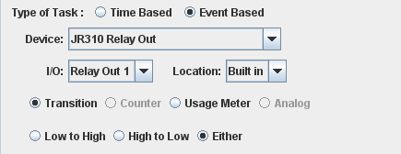

4 Relay Output Expansion Module – monitors the state of up to eight (8) relay outputs on the expansion boxes (4 relay outputs per expansion box and up to 2 expansion boxes) when the output state changes from low to high, high to low, or either. The expansion modules do NOT have usage meters. Only transitions can be monitored.

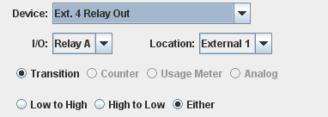

When using an external relay output in an ‘event’, the user must select whether the expansion module to be used is External 1 or External 2. Each output is lettered A, B, C or D on the expansion module label and the user must select one of these as the trigger. However, when using the 4 Relay Output Expansion Module outputs as part of an ‘action’, they are numbered 9 through 16.

NOTE: You must reboot the JNIOR with the 4 Relay Output Expansion Modules connected to the JNIOR Sensor Port so the JNIOR can assign External 1 and External 2 and output numbers 9 – 12 and 13 – 16, as needed.

The following is a screen shot of the main JNIOR web page External tab with two 4 Relay Output Expansion Modules connected. Outputs 9 through 12 is External 1 and outputs 13 through 16 is External 2.

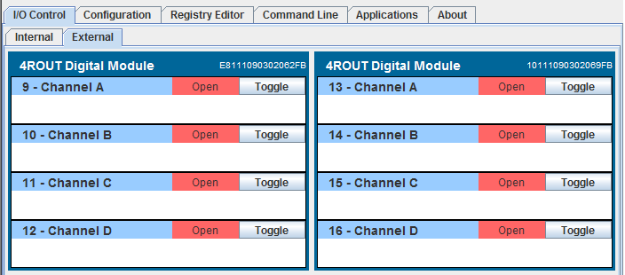

JNIOR Analog Event

An event can be triggered based on changes in the JNIOR 310 Analog I/O expansion modules that are added to the JNIOR via the Sensor Port.

The analog ‘input’ events can be triggered based on a ‘rising’ analog signal. When this value is met or exceeded the event will be triggered. A ‘reset’ value must be entered and is used as the value the analog signal must go ‘below’ before the input trigger can be used again. This allows the user the flexibility to adjust the event trigger to meet the dynamics of the process and prevent rapid oscillation. The two values will provide a dead band around the trigger event.

The analog event can also be triggered on a ‘decreasing’ analog signal by not-checking the On Rising box. In this case the ‘reset’ value is the value the analog must exceed before the trigger can be used again.

The following analog modules are available for use with the JNIOR and Task Manager:

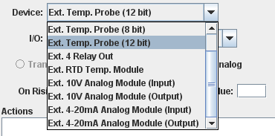
The trigger and reset values for the analog events are based on the ‘scaling’ set for the particular analog signal (input or output) or temperature signal. The ‘scaling’ for each analog signal is set using the JNIOR Web page.

Temperature Sensor – The numbers will be Fahrenheit or Celsius depending if the Fahrenheit box is checked or not checked in the temperature sensor box on the JNIOR web page.

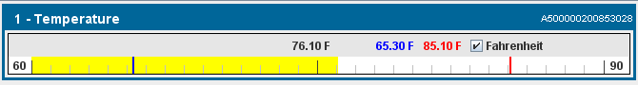

Analog Modules

The scaling for the analog modules is set by ‘right-clicking’ on the analog module in the JNIOR web page and selecting the appropriate channel.

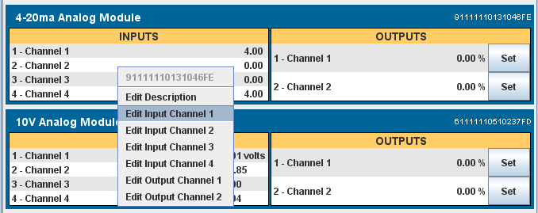

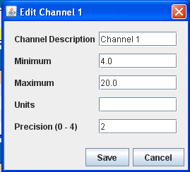

Whatever you set as the Minimum and Maximum range will be the scaling range for the trigger and reset points.

External Temperature Probe (8 bit) – the 8 bit temperature probe is selected when you have the Maxim Dallas chip that has a One-Wire ID ending in 10. There can be up to two sensors connected and identified as External 1 and External 2.
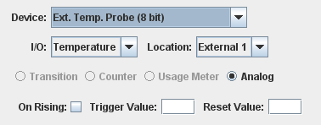

If you do not know the ID of your temperature sensor, it can be found on the External Tab in the JNIOR Web page.

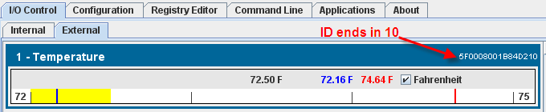

External Temperature Probe (12 bit) – the 12 bit temperature probe is selected when you have the Maxim Dallas chip that has a One-Wire ID ending in 28. There can be up to two sensors connected and identified as External 1 and External 2.
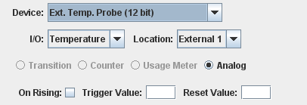

If you do not know the ID of your temperature sensor, it can be found on the External Tab in the JNIOR Web page.

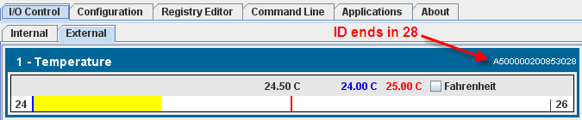

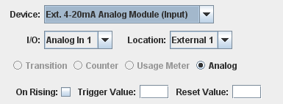
External 4-20 mA Analog Module (Input) – the 4 – 20 mA module has 4 inputs per module and there can be up to two modules connected and identified as External 1 and External 2.

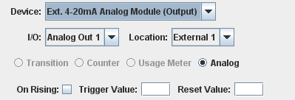
External 4-20 mA Analog Module (Output) – the 4 – 20 mA module has 2 outputs per module and there can be up to two modules connected and identified as External 1 and External 2.

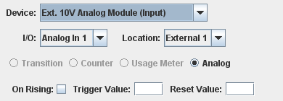
External 10 V Analog Module (Input) – the 10 VDC module has 4 inputs per module and there can be up to two modules connected and identified as External 1 and External 2.

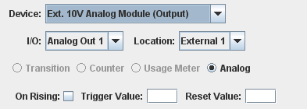
External 10 V Analog Module (Output) – the 10 VDC module has 2 outputs per module and there can be up to two modules connected and identified as External 1 and External 2.

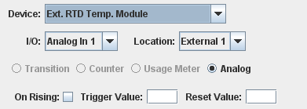
External RTD Module – the RTD module has 4 inputs per module and there can be up to two modules connected and identified as External 1 and External 2.

Editing an Existing Task

To edit a new or existing Task simply click on the Task name in the list box on the left. Any previously stored values will be loaded into the form.

For a Task to be deemed active for the current 24 hour period, it must be ‘enabled’ and set to run on the current day of the week.

In order for a Task to run all day you must have the start time and end time be 00:00:00. If the start and end time are any other time besides midnight then the Task will only trigger between the start and the end times.

Note:
If the end time is less than the start time then the Task will only trigger at the start time. It does not mean that it will, for example, run from 18:00 today until 4:00 tomorrow. Two separate Tasks would need to be made. One that runs from 18:00 to midnight today and another that runs from midnight to 4:00 tomorrow. You can do this by making one Task and following the steps outlined in the following section for “Duplicating a Task”.

Removing a Task

To remove a Task, highlight the one you want removed in the left edit box and press the ‘Remove Task’ button. It will then be permanently removed from the Task Manager program.

Duplicating a Task

If you have several Tasks that are the same except for a small difference, such as a different I/O number, then you can duplicate a Task by simply typing a new name for the Task you want to duplicate in the Task Name box. After you click on Save Changes, another Task will be created identical to the current one with the new name. Click on the new Task name in the left list box and make the required changes to the new Task.

Running a New or Changed Task

When you click on the Save Changes button, Task Manager will save the changes made to the JNIOR and then stop and restart the event monitor routine so that all the tasks are reloaded by the program. All changes must be made through the Task Manager user interface because this is the only method for Task Manager to recognize changes to existing tasks or new tasks. Otherwise a reboot would be required.

Actions

A valid Task must consist of a name and at least one Action. You can have multiple Actions per Task. The limit on the number of Actions you can have is a function of the number of characters that can be passed between the Task Main web page (applet) and the JNIOR and is currently limited to 255. Therefore, a label indicating the total number of characters used out of 255 is provided above the list box for the Actions (for example, 128/255 characters used in the screenshot below). The numbers will turn red when the number of characters exceeds 255.

The Actions will occur in the order that they are shown in the list box. If you want to log to a file and then clear the counters, you must make an Action for logging and one for clearing in that order. If the order is incorrect, you can highlight an Action and use the ‘Move Up’ and ‘Move Down’ buttons to the right of the list box.

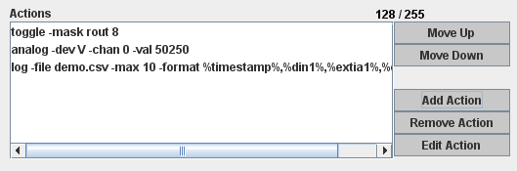

Delayed Execution

An action can have a ‘delayed execution’ which means that Task Manager will wait approximately the number of seconds entered at the bottom of the Action configuration box before the Action is executed. The value to be entered can be any whole number equal to or greater than one (1).

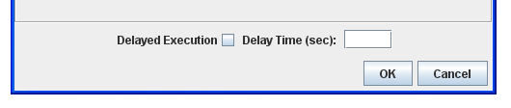

Adding an Action

To add an Action to the current Task simply click on ‘Add Action’ and fill in the form. If the form is not properly completed then it will alert you to the errors that are keeping the form from being valid. There are five different types of Actions.

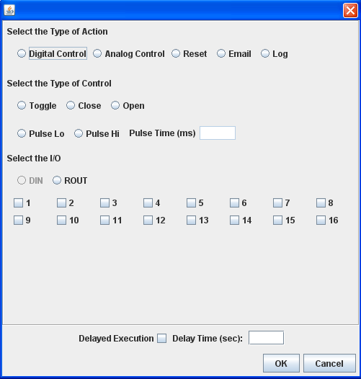

(1) An Action can be configured as Digital Control (Toggle, Close, Open, Pulse Lo or Pulse Hi) of any one relay output on the JNIOR. The outputs 9 – 16 will work according to the number of 4 Relay Output Expansion Modules attached to the JNIOR.

(2) An Action can be configured as Analog Control (sets an analog output to the value entered) of any analog output. Analog outputs are available on the 4- 20 mA Analog Expansion Module and the 10 VDC Analog Expansion Module. There can be up to 2 analog expansion modules creating a total of 4 analog outputs available.

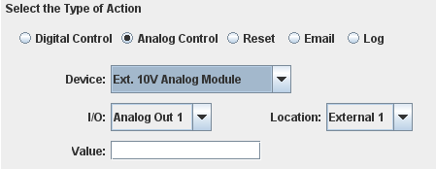

(3) An Action can be configured to Reset a Counter or Usage Meter for any one digital input or Reset a Usage Meter for any one relay output (1 – 8 only) on the JNIOR.

(4) An Action can be configured to send an E-mail via the JNIOR as part of the Task. The e-mail profile to be used is defined via the JNIOR main applet. The profile contains the e-mail addresses of the recipients, the subject, the message and any files to be attached (i.e. the log.csv file). The generation and sending of an e-mail via the JNIOR can take anywhere from a few seconds to a minute or more when attachments are used.

(4) An Action can be configured to Log data from the JNIOR to a CSV or text formatted file. Logging requires you to enter a file name, a maximum file size in kilobytes, and a list of the data to be logged in the file.

Logging Format

The log action window is shown below. The user must enter the file name. If the .csv extension is added, then the file will be saved as Comma Separated Values (CSV format). A CSV file will open directly in a program such as Microsoft Excel.

Take caution when entering the maximum file size. There is a maximum of 1 MB RAM available for logging and the way the logging system works is it will log until the file size is reached, then create a back-up file (‘name’.bak) and start a new file. So you can actually end up with 2 files of data until the second time the file is full and the .bak file is overwritten.

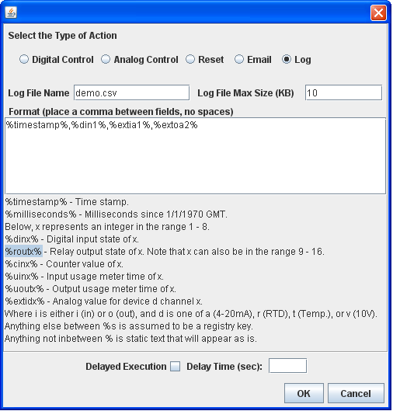
TIP: Left-click to highlight, then Ctrl-C to copy and Ctrl-V to paste in format window

In the format window, the user can enter any combination of data to log, however, the characters all count towards the maximum of 255 characters for all the actions. The items in the list must contain a % sign at the beginning and end of each variable name and each variable name must be separated by a comma.

TIP: You can ‘highlight’ the various items in the log pop-up window to copy them (ctrl-c) and paste (ctrl-v) the text into the Format box. This will save you the time of typing each item to log. You will have to edit each one for the specific data point and you must enter a comma between each.

The variables that can be logged include a timestamp, number of milliseconds since January 1, 1970, the state of any digital input or output (output states can be 1 – 16), counter values, usage meters, analog input and output values (via the expansion modules) or any value in the Registry.

For the analog expansion modules, the format is as follows:

%extidx%

Where i, d and x are defined as follows:

i is either i for ‘input’
o for ‘output’

d is either a for the 4 – 20 ma module
r for the RTD module
t for the temperature sensors
v for the 10 VDC module

x is the number of the input or output as shown in the JNIOR Web page, External tab

An example of the logging format is as follows;

%timestamp%,%din1%,%cin4%,%rout10%,%extia1%,%extoa4%

This will create a line in the file that will hold the current time stamp, state of digital input 1, counter value for input 4, relay output status for output 10 (second output on first 4 ROUT expansion module), analog value for analog input 1 (first analog input on the first 4 – 20 mA expansion module) and analog value for analog output 4 (second analog output on the second 4 – 20 mA expansion module).

For the filename, if you do not add the .csv extension or any other extension, the file will be stored as a text file. For the file location, if you just put the filename, the file will be stored in the root directory. If you add a folder name before the filename followed by a forward slash (/), the JNIOR will store the file in that folder. For example, www/log.csv will create a csv formatted file stored in the www directory on the JNIOR.

There is a difference when storing a file in the www directory because it can be accessed via a web browser. For example, typing the JNIOR IP address/log.csv (i.e. http://10.0.0.200/log.csv) will cause the file to be displayed in Internet Explorer using Microsoft Excel. If the file is only named “log”, then typing the JNIOR address/log (i.e. http://10.0.0.200/log) will display the contents of the file in text format in your web browser. The www directory is the source for any data or web pages to be viewed from the JNIOR.

When the Action is executed the first time, the file will be created and the names of the variables will be written to the first line in the log file.

After you have configured your Action, click on the OK or Cancel button.

Editing an Action

To edit an Action you must highlight an Action in the list box and then click on ‘Edit Action’. Make the required changes and click on OK or Cancel.

Removing an Action

Highlight the Action you wish to remove and click ‘Remove Action’.

Saving Your Changes

After you have made changes to a Task or an Action, you will be required to Save Changes or Cancel Changes on the main web interface page. This will cause Task Manager to reload all the tasks with their new configuration.

