Serial Control PLUS Manual

INTEG Process Group, Inc.
2919 East Hardies Rd, First Floor
Gibsonia, PA 15044

PH (724) 933 - 9350
FAX (724) 443 - 3553

www.integpg.com
support@integpg.com
sales@integpg.com

© 2020 INTEG Process Group, Inc.
All Rights Reserved

Last updated on: August 24, 2020
TABLE OF CONTENTS

1 What is the Serial Control PLUS Function? 3
2 The Purpose of the Serial Control PLUS Function 3
3 Connecting an Ethernet Device 3
4 Enabling the Serial Control PLUS Software 4
5 Installing the Serial Control PLUS Software 4
6 Configuring the Serial Control PLUS Software 5
7 Serial Control PLUS Commands 7
8 Options 9

What is the Serial Control PLUS Function?

The Serial Control PLUS function for the JNIOR is a software application that runs on the JNIOR and allows the user to interact with the JNIOR I/O via the serial port and/or an Ethernet connection. (Serial Control PLUS is an enhanced version of the Serial Control program that only worked via the serial port. This manual still applies to the Serial Control program with the exception of the Ethernet connection.) The user can control the relay outputs (on, off, pulse), receive the status of the digital inputs (on, off) and receive the counter values. The user can interact with the JNIOR I/O via the serial port and the Ethernet port at the same time.

The Purpose of the Serial Control PLUS Function

The Serial Control PLUS function can be used in applications where the user’s external device cannot communicate over the Ethernet, but can communicate via an RS232 port. Or the device has an Ethernet port, but does not have a driver for the JNIOR protocol or Modbus protocol. The user’s device must be able to send simple ASCII commands to the JNIOR as defined later in this manual.

Connecting an Ethernet Device

When the JNIOR is on an Ethernet network, any device on the network can send the ASCII commands to the JNIOR. The default port on the JNIOR that is listening for the commands is 9202. The user can change this port via the JNIOR Web page.

Enabling the Serial Control PLUS Software

The Serial Control software is pre-installed on all JNIORs. To activate the software so that it runs on boot up, please launch the main JNIOR web page in the JNIOR Support Tool, go to the Configuration tab and under the Applications section should the pre - downloaded applications should be. Check the Serial_Control Converter box. If you don’t have, or are unfamiliar with the JNIOR Support Tool, please look at its manual located on INTEG’s website.

If you want to utilize the Ethernet connection, then you must upgrade to the Serial Control PLUS software as described next.

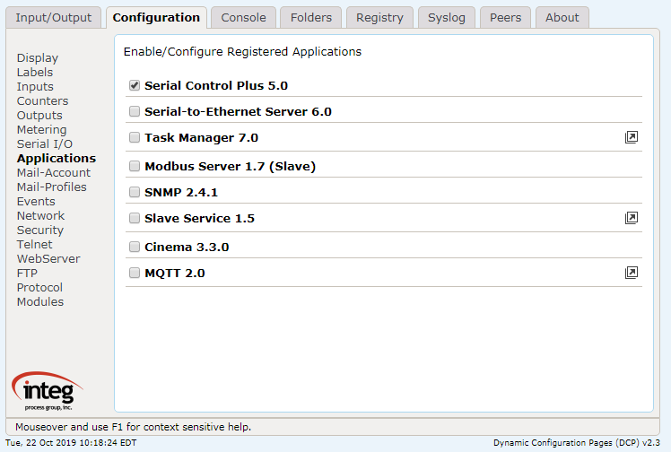

Installing the Serial Control PLUS Software

The Serial Control PLUS software is available from INTEG or via the INTEG website on the JNIOR downloads page. Please download the ‘Serial Control PLUS Update’ project that will be used with the JNIOR Support Tool. Do NOT unzip the update project. The JNIOR Support Tool will unzip it. On the Update tab in the JNIOR Support Tool, click Open Project, select the Serial Control PLUS Update project and then Publish the update to your JNIOR. The software will be loaded, the run key set and the JNIOR rebooted.

Configuring the Serial Control PLUS Software

Once the Serial Control PLUS program is running, it will be ready to accept clients on the auxiliary serial port or via an Ethernet connection over port 9202. The default setting for the AUX serial port is 9600 baud, 8 data bits, 1 stop bit, no parity and flow control set to none. What this means is that the serial device connected to the JNIOR serial port must work with the above serial settings otherwise you will have to change the settings on either the JNIOR or your device.

The Registry Editor tab on the JNIOR Main Web page can be used to change any settings for the Serial Control PLUS software program. After you enable the Serial Control PLUS program and it is running after a reboot, the default settings are displayed in the Registry Editor and are as shown below:

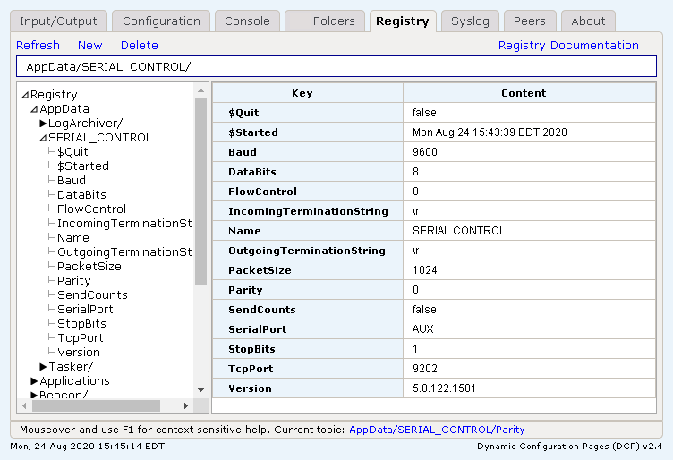

To modify any of the above Registry Keys, click on the appropriate key and then the Edit Key button. Make any changes and click the Save button. Your change will be saved.

Registry Key | Default | Valid Settings | Comments
Baud | 9600 | 300, 600, 1200, 2400, 4800, 9600, 19200, 38400, 57600, 115200 | No reboot required
DataBits | 8 | 7 or 8 | No reboot required
FlowControl | 0 | 0, 1 or 2 where:  0 = none  1 = CTS/RTS (hardware)  2 = XON/XOFF (software) | No reboot required
IncomingTerminationString | \r | \r = carriage return  \n = line feed  \r\n = carriage and line feed  Any character recognized by the user’s program | This is the character that signals the JNIOR that it is the end of the data
OutgoingTerminationString | \r | \r = carriage return  \n = line feed  \r\n = carriage and line feed  Any character recognized by the user’s program | This is the character that signals the DEVICE that it is the end of the data
PacketSize | 1024 | 1 to 1024 bytes | The size of the data packet to be sent, usually not adjusted
Parity | 0 | 0, 1, or 2 where:  0 = no parity  1 = odd parity  2 = even parity | No reboot required  Supports:  8 databits, 1 stop bit  7 databits, 2 stop, no parity  7 databits, 1 stop, with parity
SendCounts | false | false or true | Reboot required  Setting this key to true will cause the count value to be sent each time the input status message is sent (for example, IN2=1,32)
SerialPort | AUX | AUX or RS232 or disabled | Reboot required – defines the serial port on the JNIOR that the serial device is connected to. (Please see Section 9 of this manual for important information.) Setting to disabled prevents the Serial Control PLUS program from taking over either serial port.
StopBits | 1 | 1 or 2 | No reboot required
TcpPort | 9202 | Any valid TCP port number not already used | Reboot required The port number that the JNIOR will be listening on for incoming ASCII commands

Serial Control PLUS Commands

After the Serial Control PLUS software is properly configured and running, you can now start to interact with the JNIOR. The JNIOR Model 410 has 8 digital inputs, 8 relay outputs and the capability to add one or two 4 Relay Output Expansion Modules. Adding the expansion modules provides the user with a total of 12 or 16 relay outputs. The expansion module relay outputs can be controlled and monitored via the Serial Control PLUS program.

The 4 Relay Output Expansion Modules are connected to the JNIOR via the Sensor Port. After the expansion modules are connected and you reboot the JNIOR, the JNIOR will assign the external relay outputs as numbers 9 through 16. The number assigned by the JNIOR will be displayed on the Main JNIOR Web page as shown below. This is the order with which you will access the external outputs via the Serial Control PLUS application. Outputs 9 through 16 will be controlled using commands +1 through +8 respectively.

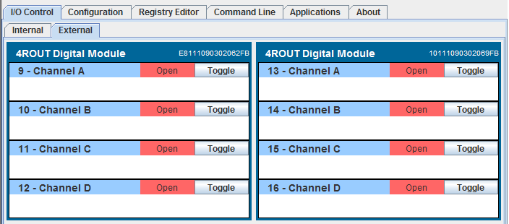

Controlling the Outputs

The following commands are available to control the relay outputs:

cX Close the output (relay is “on” closing the contact)
where x = 1 through 8 for the internal relay outputs on the JNIOR 310
and x = +1 through +8 for the external relay outputs on the 4 Relay Output Expansion Modules

oX Open the output (relay is “off” opening the contact)
where x = 1 through 8 for the internal relay outputs on the JNIOR 310
and x = +1 through +8 for the external relay outputs on the 4 Relay Output Expansion Modules

p=yyy Pulse duration (milliseconds) and is used in conjunction with the ‘close’ or ‘open’ command

Examples:
c2p=1000 close output 2 for 1 second and then open again
c+2p=1000 close output 10 for 1 second and then open again
o3p=10000 open output 3 for 10 seconds and then close again

c* Close all outputs at the same time (includes internal and external)

o* Open all outputs at the same time (includes internal and external)

These commands can be abbreviated and used in combination, such as:

c1 close relay output 1
c+1 close relay output 9 (first output on first expansion module)
c+5 close relay output 13 (first output on second expansion module)
c1+1+5 combination of the above all in one command
c1234 close relay outputs 1 through 4
c1368 close relay outputs 1, 3, 6, 8
o125 open relay outputs 1, 2, 5
c1+1p=1000 close relay outputs 1, 9 and pulse each for 1 second simultaneously

Monitoring the Inputs, Outputs and Counters

Whenever an input (or output) changes status (low-to-high or high-to-low), the following is sent out by the JNIOR:

INx=1 Input x (1 – 8) has gone high (on)
OUTx=1 Output x (1 – 16) has gone high (on)
INx=0 Input x (1 – 8) has gone low (off)
OUTx=1 Output x (1 – 16) has gone low (off)

The default setting for the Registry Key AppData/Serial_Control/SendCounts is false. If you change this key to true and reboot, with each message stating the input status, a count value will also be included. Whenever an input changes status (low-to-high or high-to-low), the following is sent out by the JNIOR:

INx=1,yyy Input x (1 – 8) has gone high (on), counter value = yyy
INx=0,yyy Input x (1 – 8) has gone low (off), counter value = yyy

Note that these monitoring messages are sent out individually over the serial port or Ethernet. The JNIOR does not report the status of more than one input/counter in the same message.

Options

The default setting for the Serial Control PLUS software is to utilize the Auxiliary Serial port located along the top edge of the JNIOR. However, it is possible to change this setting to utilize the RS-232 serial port located along the bottom edge of the JNIOR. It is important to understand that the primary purpose of the RS-232 port is to act as the command console for the JNIOR. The command console allows the user to connect to the JNIOR via a program such as HyperTerminal for configuration purposes. And although they are not visible to the user unless connected, the JNIOR will write certain system messages to this port.

If you desire to use this port for your serial device, then you must start the Serial Control PLUS software as described above so that the Registry Keys are displayed. Using the main JNIOR web page, edit the SerialPort key and change the value to RS232. You must reboot the JNIOR (a soft reboot via the About tab or a Telnet window is preferred) and when it finishes, the Serial Control PLUS software will now use the RS-232 port.

IMPORTANT: Every time the JNIOR reboots, it waits 1 minute before taking over the RS-232 port for the Serial Control PLUS application. This would allow you some time to connect to the JNIOR via HyperTerminal for an emergency where you no longer knew the JNIOR IP address and had no other way to connect to the JNIOR. You would have 1 minute to log in and type ‘ps’ at the prompt to list all the running processes and then type ‘kill X’ where X is the process number for the serialcontrol.jnior program.

The program will stop immediately and you will have time to change your ipconfig or go to the Command Line registry editor and delete the Run key for the Serial Control PLUS software program. When the Run key is deleted, the program will no longer automatically run after boot.

NOTE: You can have both Serial Control PLUS and Serial-to-Ethernet (see the Serial-to-Ethernet Manual) programs running on the same JNIOR at the same time as long as they are using different serial ports. You must start the program first that will be using the RS232 port and change its default setting from AUX to RS232. Then you can start the other program because it will now be able to run and use the Auxiliary Serial port. Having both programs running at the same time with both of them configured for the Auxiliary Serial port could cause unexpected operation of your JNIOR.
Summary

Thank you for purchasing the JNIOR. Hopefully this manual made the getting-to-know process of your new JNIOR very quick and easy. The JNIOR has many more wonderful tools and features available, and are explained in detail in the supplied documents.

Copyright Copyright © 2020 INTEG Process Group, Inc.
All rights reserved.

Notice Every effort was made to make this manual as accurate and useful as practical at the time of the writing of this manual. However, all information is subject to change.

Trademarks Trademarks are the property of their respective holders.
Sun, Sun Microsystems, the Sun logo and Java are trademarks or registered trademarks of Sun Microsystems, Inc. in the United States and other countries.
Microsoft, Windows, MS-DOS and Internet Explorer are registered trademarks of Microsoft Corporation.

Use Restrictions This User’s Manual and the software contained in the JNIOR are copyrighted by INTEG Process group and may not be copied or reproduced without prior consent from INTEG Process Group, Inc. INTEG Process Group is not responsible for any errors or omissions that may be contained in this manual.

Please do not hesitate to contact our JNIOR team at INTEG Process Group, Inc. We can be reached via phone, fax or e-mail as follows:

INTEG Process Group, Inc.
2919 East Hardies Road, First Floor
Gibsonia, PA 15044

www.integpg.com
sales@integpg.com
support@integpg.com

PH (724) 933-9350
FAX (724) 443-3553

