JNIOR Series 4
A Network I/O Resource
Utilizing the JAVA™ Platform

DMX Control Program

Release 2.0

NOTE: This application works with the JNIOR 412DMX and JNIOR 410

INTEG Process Group, Inc.
2919 East Hardies Rd, First Floor
Gibsonia, PA 15044

PH (724) 933 - 9350
FAX (724) 443 - 3553

www.integpg.com
support@integpg.com

© 2019 INTEG Process Group, Inc.
All Rights Reserved

Last updated on: June 24th 2020
TABLE OF CONTENTS

1 Introduction 3
2 Launching the DMX Configuration Web Page 4
3 Configuring DMX Fixture Types 5
4 Configuring DMX Physical Fixtures 8
5 Configuring Scripts 9
6 JNIOR I/O Triggers 13
7 DMX Control Panel 15
8 Remote Control to Trigger Scripts 17
8.1.1 Remote Control via the INTEG Cinema Program 18
10 INTEG 3 Channel LED Dimmer Module 20

Introduction

The DMX Control Program is used to control 512 DMX channels via the JNIOR. The JNIOR Model 412DMX contains a 5-pin DMX port. Alternatively, you can create a serial to DMX cable for the JNIOR Model 410 since its AUX serial port has the capability to handle the DMX control and utilize the DMX Control Program. The DMX Control Program works the same on either model.

The JNIOR 412DMX is shipped with the DMX Control Program installed and running. An update project is available on the INTEG website under the Support section with the latest version and/or to install it on the JNIOR 410.

The JNIOR is shipped with the default IP address of 10.0.0.201. You can change the IP address using the JNIOR Support Tool. Please see the JNIOR Series 4 Getting Started Manual.

The main JNIOR web page – the Dynamic Configuration Pages (DCP) – is launched either via the JNIOR Support Tool (Beacon tab) or by typing the JNIOR IP address into your browser. To log into the DCP and the DMX web page, please use the following:

Default username: jnior
Default password: jnior

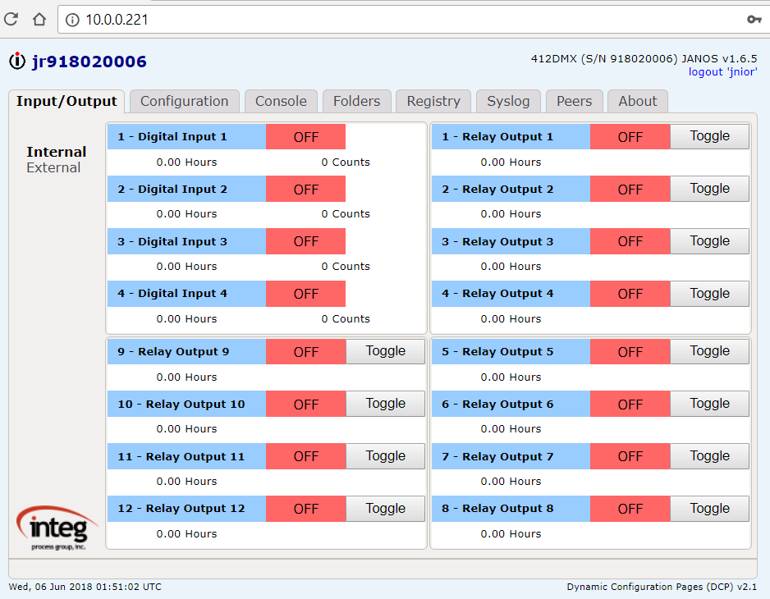

Launching the DMX Configuration Web Page

The DMX Configuration web page can be launched by launching the DCP and going to the Configuration tab and Applications page and then clicking on the launch web page icon as shown below.

Or by typing the DMX web page URL directly in your browser:

http://10.0.0.201/dmx where 10.0.0.201 is the JNIOR IP address

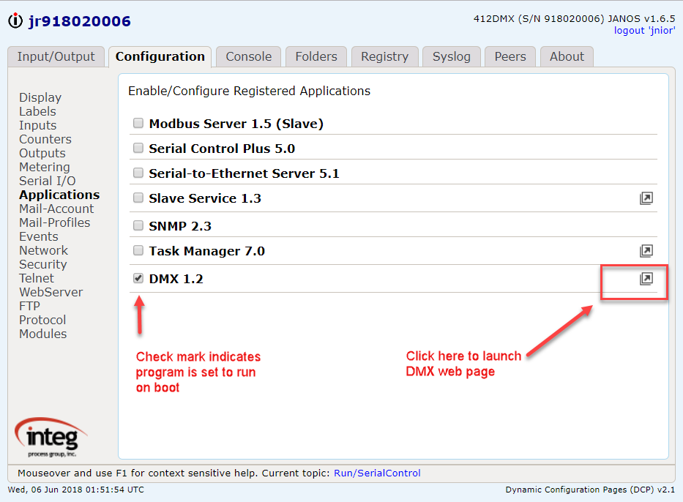

NOTE: Make sure to check the Serial I/O section of the configuration tab so that your aux serial port does not have RS-485 mode enabled. If it is, disable it or the dmx.jar application cannot communicate to the dmx device you’re using.

Configuring DMX Fixture Types

When the DMX web page is launched, it opens on the Fixture Types tab as shown below. The Fixture Types tab is used to configure standard fixtures that will be used and controlled by the JNIOR. Click on the Fixtures Type tab and the following is displayed.

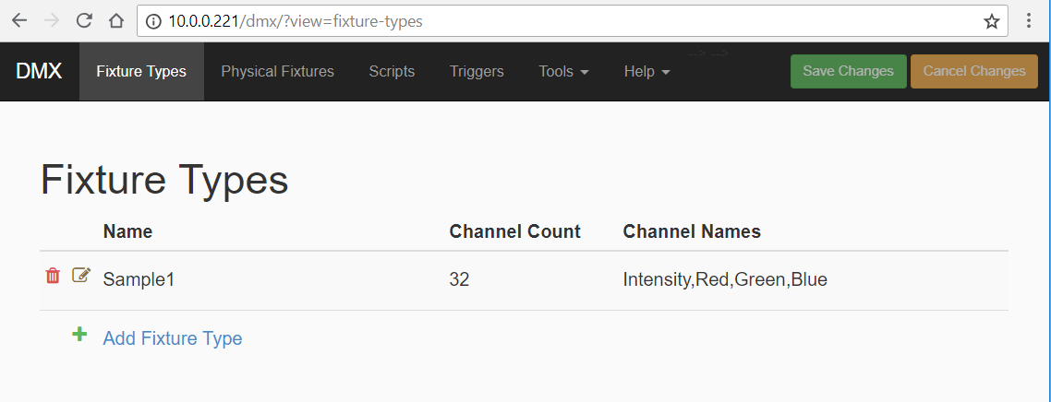

When you click on the Add Fixture Type link, a pop-up will be displayed that allows you to enter a fixture type name and the standard number of channels for this fixture’s personality. When you enter the Channel Count, the appropriate number of fields will be displayed to add a description for each channel for this specific type of fixture.

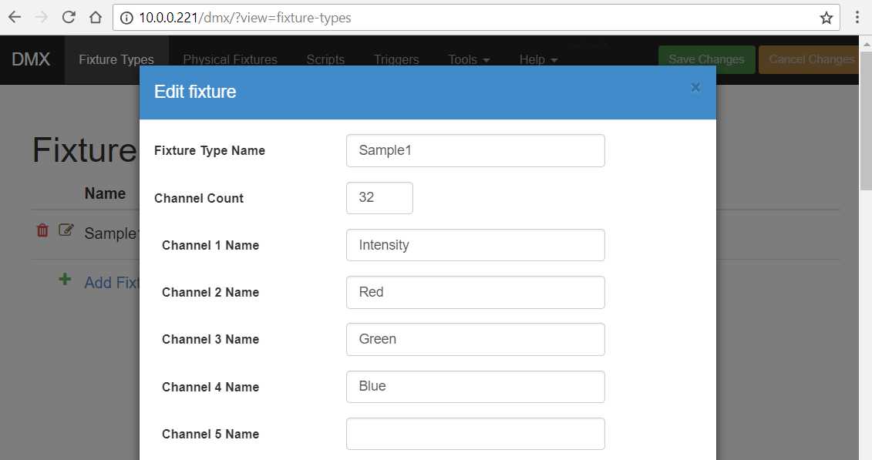
NOTE: Whenever you make changes on any page in the DMX web page, your change is NOT saved until you click on the Save Changes button at the top of the page. Or you can click on the Cancel Changes button to remove any changes made.

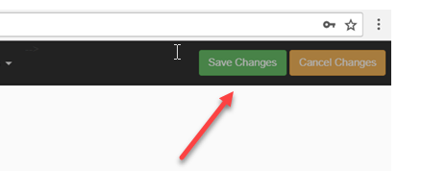

Any changes you make are displayed in YELLOW until you click on the SAVE CHANGES or CANCEL CHANGES button.

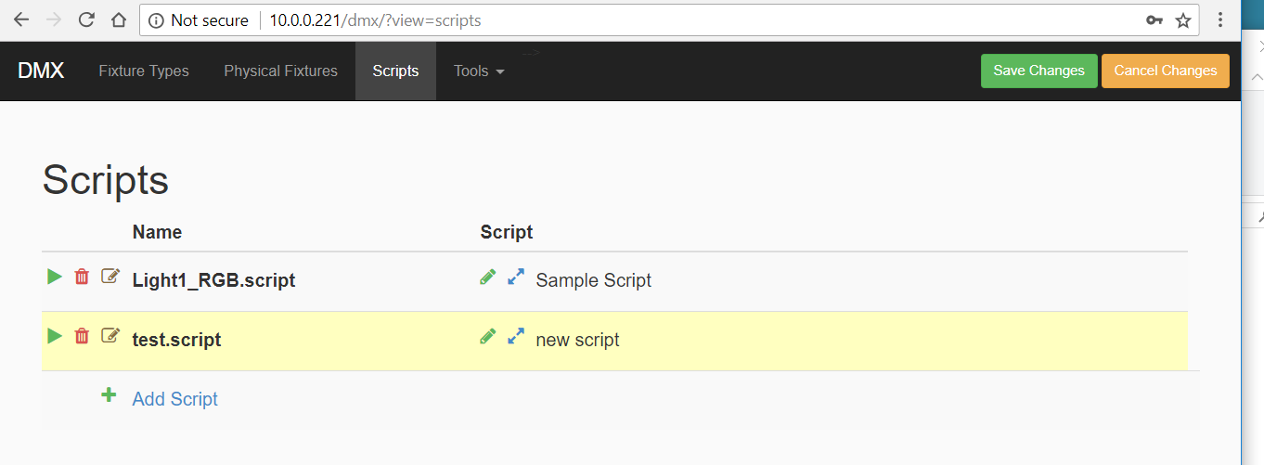

When you remove (delete) any item, by clicking on the red garbage can icon, you are asked to confirm that you want to delete the item.

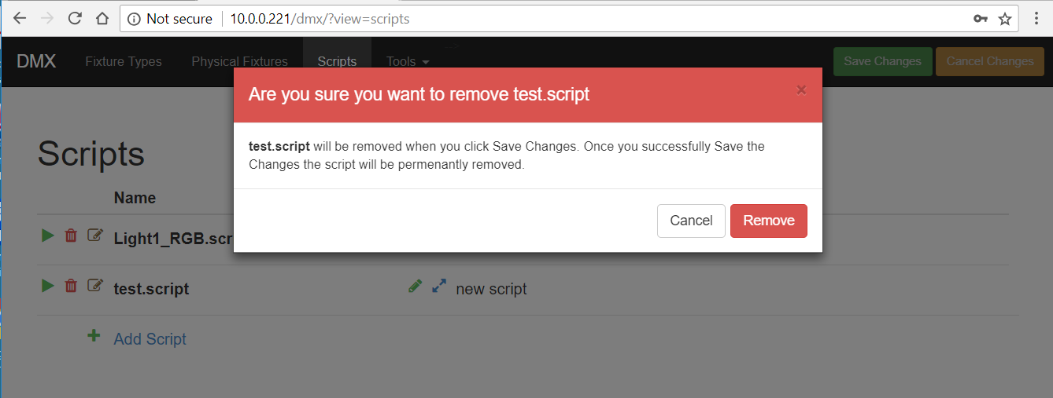

The item is displayed in RED until you click on the SAVE CHANGES or CANCEL CHANGES button.

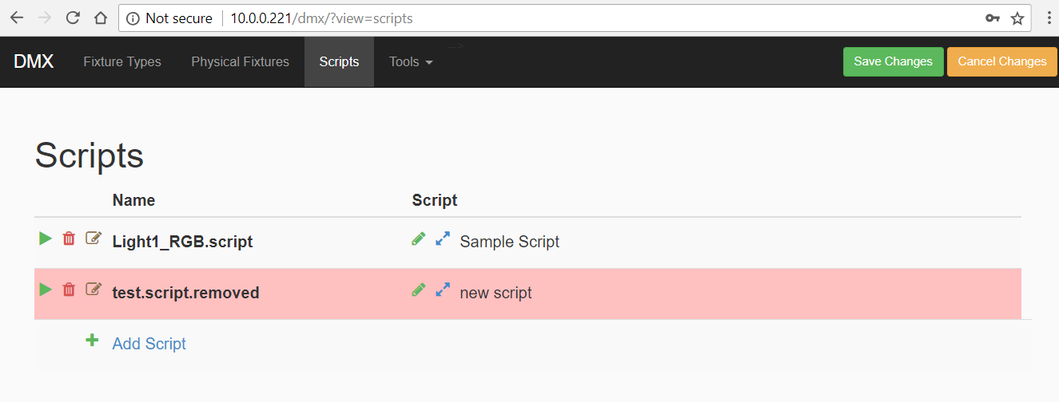

Whenever you click on the Cancel Changes button, you are asked to confirm that you want to undo the changes you made.

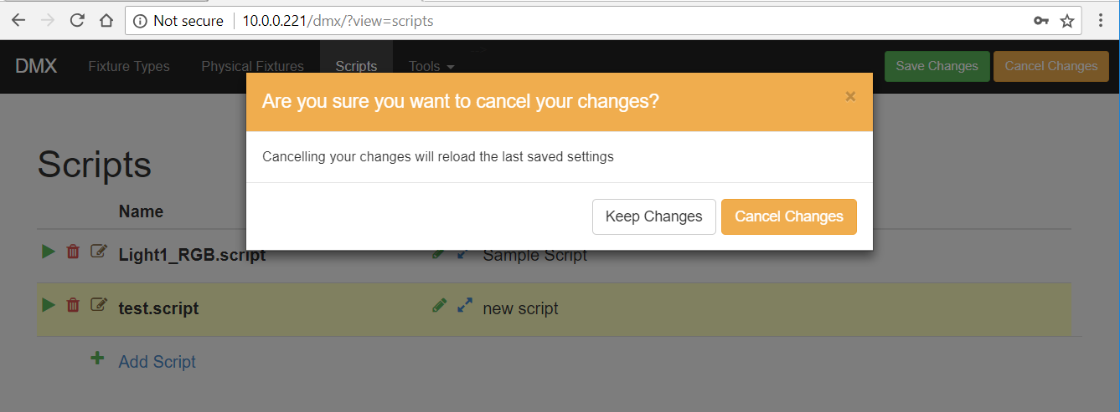

Configuring DMX Physical Fixtures

After you have configured your Standard DMX Fixture Types, you can create your specific Physical Fixtures being controlled by the JNIOR. You can have multiple Physical Fixtures using the same Standard DMX Fixture Types. Click on the Physical Fixtures tab and the following is displayed.

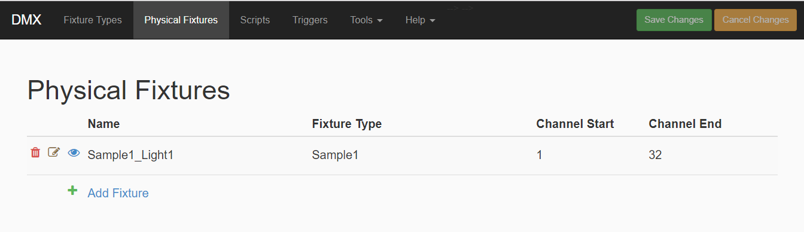

When you click on the Add Fixture link, a pop-up will be displayed that will allow you to select the Standard Fixture Type (a pull down will list all the types available) to use for this Physical Fixture, enter a fixture name and then enter the starting DMX Channel (between 1 and 512) to be used for this fixture. As with all DMX fixtures, you can elect to use the same starting DMX address for the same Fixture Type or unique starting channel addresses.

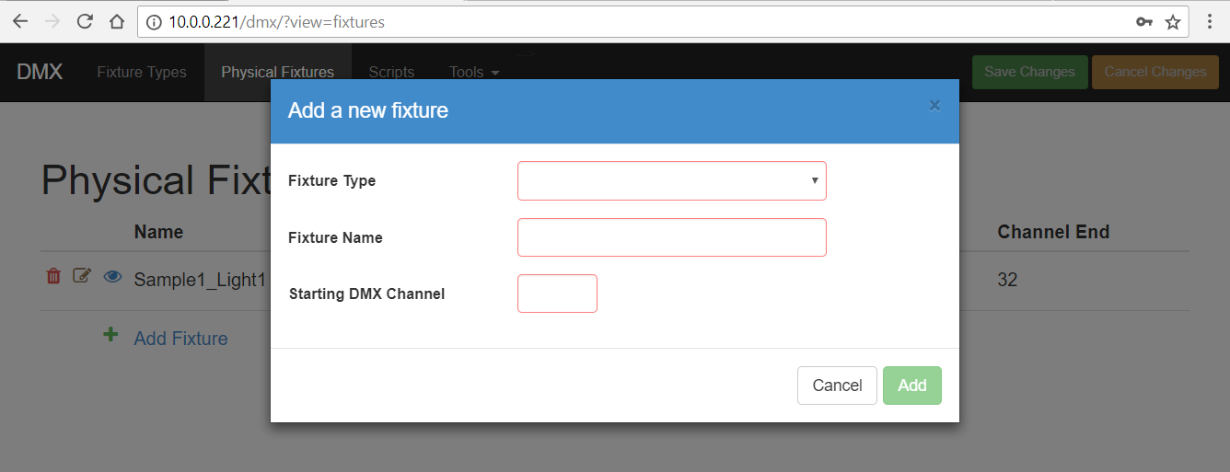

Configuring Scripts

The DMX Control Program allows you to configure scripts for controlling your DMX fixtures. A script contains various commands including ‘setting’ one or several channels and ‘delays’ in between each ‘set’ command or specific times to execute a ‘set’ command. Click on the Scripts tab and the following is displayed.

NOTE: Executing scripts is how you can control the DMX Fixtures to do certain commands. You DO NOT need other JNIOR applications in order to command these scripts.

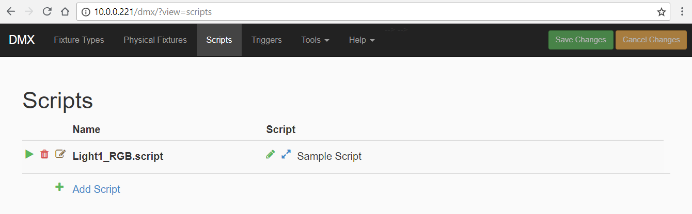

When you click on the Add Script link a pop-up will be displayed so you can name the script.

NOTE: The script name CANNOT have spaces. Please use the ‘underscore’ to separate words, for example Light1_RGB

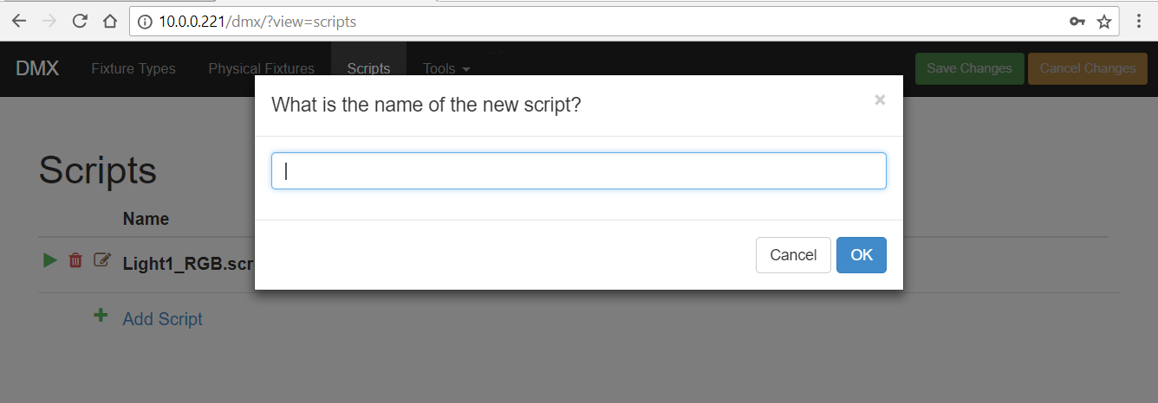

After you have added your new script name, if click on the brown icon with the ‘paper and pencil’, you can create and edit your script name.

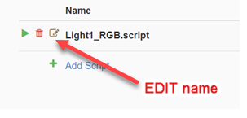
NOTE: If you change a script name, you MUST reboot the JNIOR for the new name to take affect.

Clicking on the green pencil will allow you to edit your script.

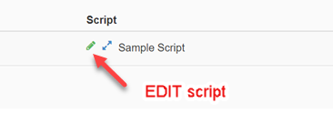

A pop-up will be displayed as shown below. You can add as many actions as you want to your script. Then click on the Set button in the lower right corner.

NOTE: Your script is not saved until you click on the Save Changes button in the upper right corner of the DMX web page.

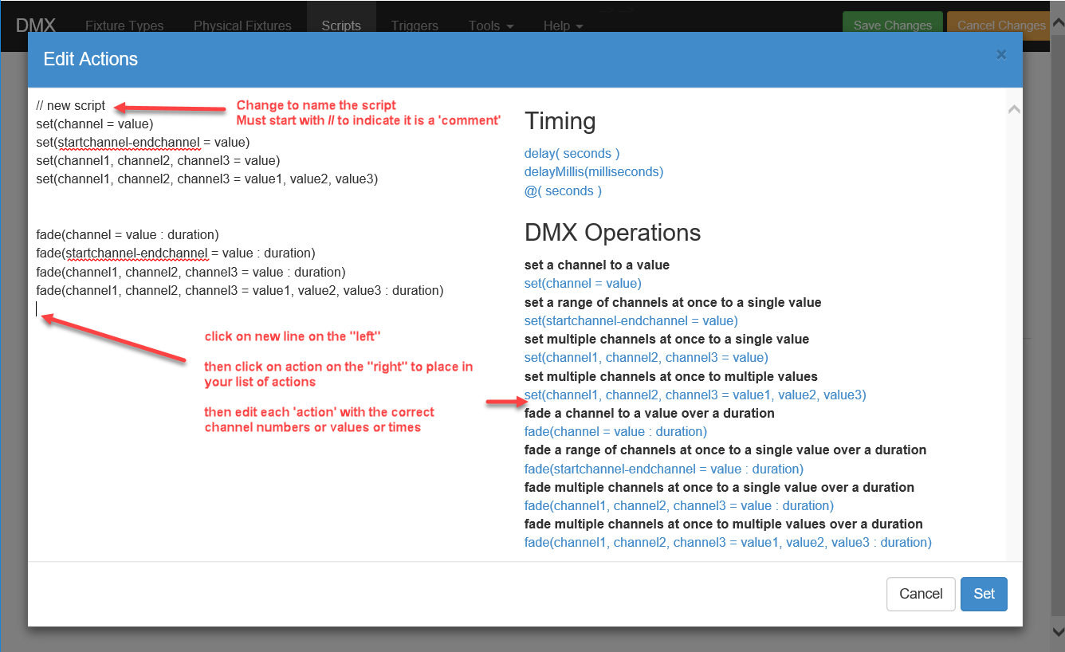
You can add comments to your script by starting the line with // The first comment line will be displayed when the script is collapsed. You can insert comments anywhere you want in your script.

Explanation of Commands

// new script
- Starts with // and indicates a comment

set(channel = value)
- Set specific Channel to a specific Value
- Channel and Value are whole numbers from 0 to 255

set(startchannel-endchannel = value)
- StartChannel is starting DMX Channel and EndChannel is ending DMX Channel and all channels in range will be set to Value

set(channel1, channel2, channel3 = value)
- Set all Channels defined to the same Value

set(channel1, channel2, channel3 = value1, value2, value3)
- Set each Channel defined to its own unique Value that is defined.

fade(channel = value : duration)
- Fade or ‘transition’ the DMX Channel from the current value to the new Value over a Duration where the duration is in whole seconds.
- Example fade(25=100:5) means channel 25 will transition from its current value to100 over 5 seconds.

fade(startchannel-endchannel = value : duration)
- Fade all channels within channel range from current value to new Value over Duration in seconds

fade(channel1, channel2, channel3 = value : duration)
- Fade specific Channels defined from current value to same new Value over saem Duration in seconds

fade(channel1, channel2, channel3 = value1, value2, value3 : duration)
- Fade specific Channels defined from current Value to unique Value defined for each Channel all over same Duration in seconds

Clicking the ‘blue arrows’ will allow you to view (expand) your script. Clicking them again will collapse the box.

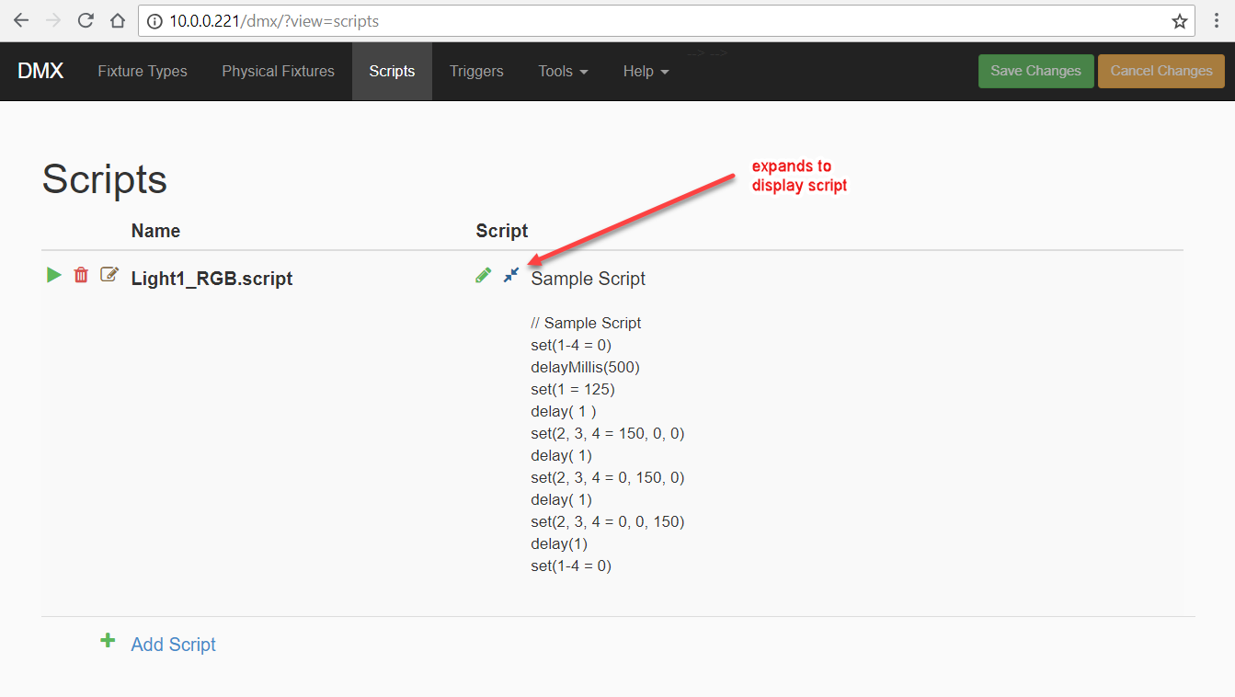

You can execute your script (AFTER you have saved your changes) by clicking on the green arrow icon. A pop-up box will ask you how many times you want to execute the script.

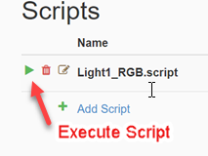

JNIOR I/O Triggers

The JNIOR Inputs and Outputs can be used to ‘trigger’ various scripts. Enter the following format into the box next to the JNIOR Input or Output as shown below.

script(script_name) where script_name is the name of your script

OPTIONS

-r # repeats script # of times

-f repeats script forever until abort command is received

abort (script_name) aborts single script called script_name

abort aborts all running scripts

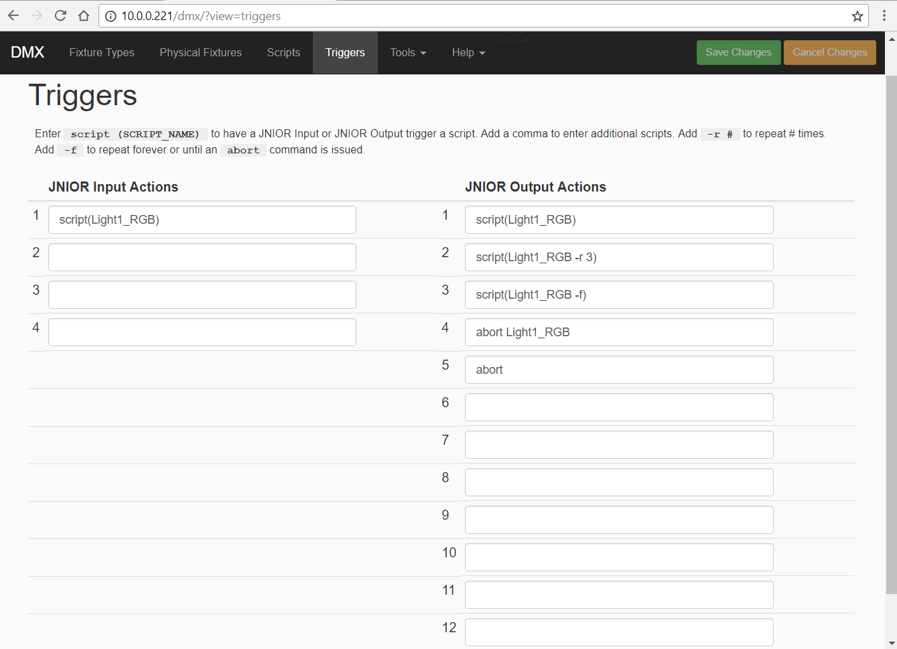

DMX Control Panel

You can manually control any DMX fixture or channel or ‘trigger’ a script by launching the DMX control panel. Click on the Tools tab and the Launch Panel dropdown will be displayed.

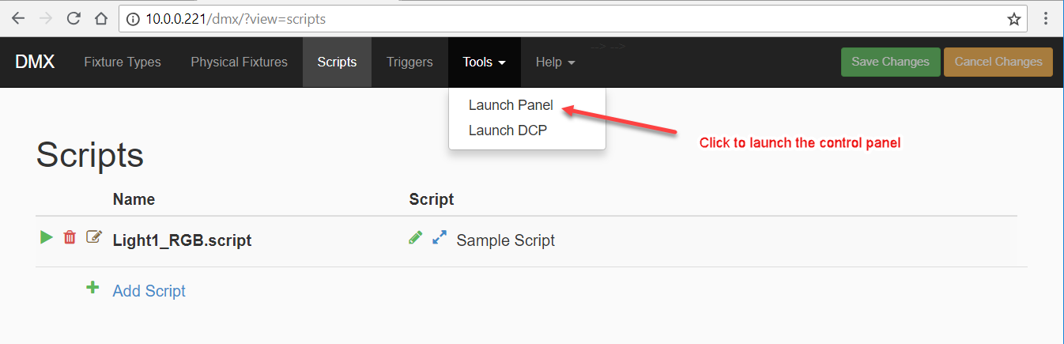

Clicking on the Launch Panel will display the DMX control panel as shown below.

NOTE: Channel values go from 0 - 255.

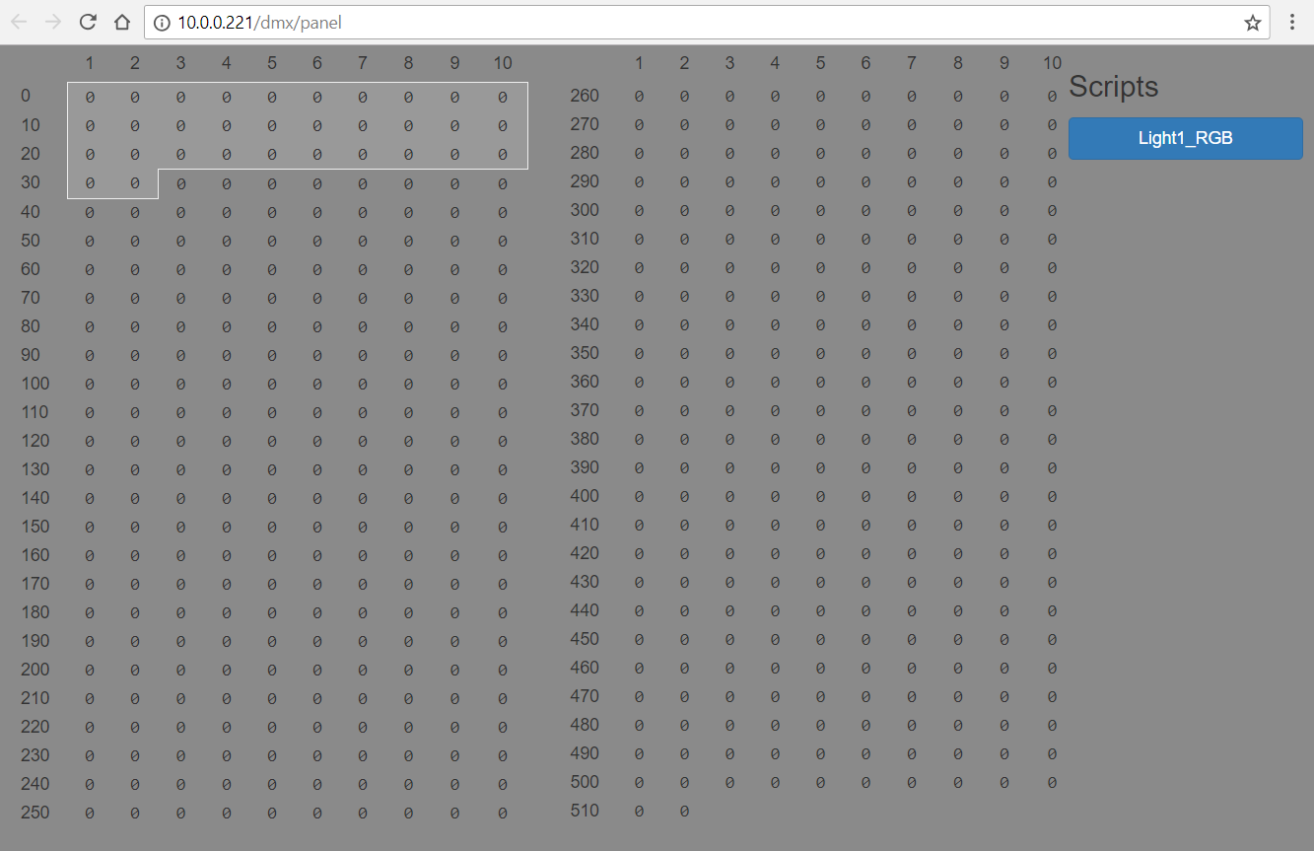

The light gray area in the control panel represents any fixture you have configured. Clicking in the light grey area will pop-up a control panel with sliders and numeric boxes to allow you to change the value of any specific DMX channel.

NOTE: Channel values go from 0 - 255.

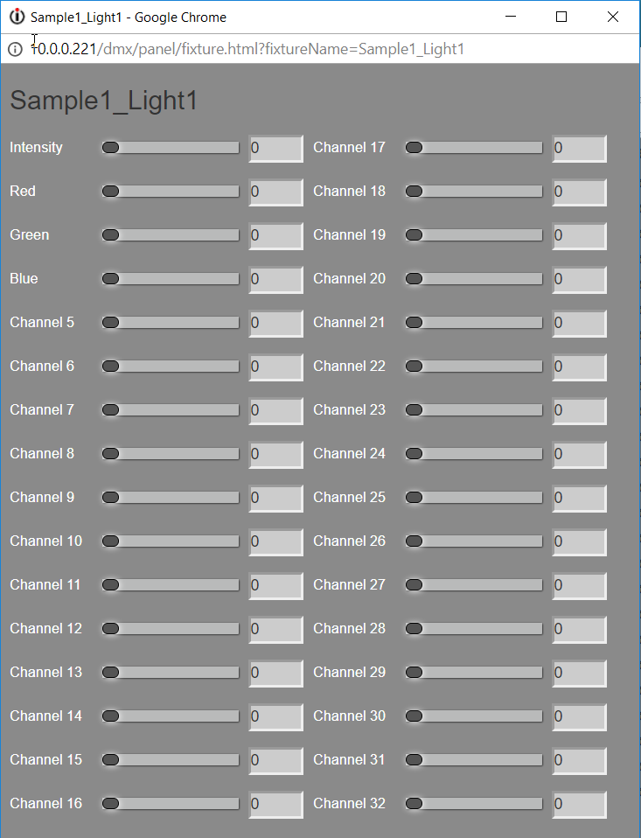

If you click in the dark grey area, you can enter a value for any other DMX channel that is not associated with a specific fixture as shown below.

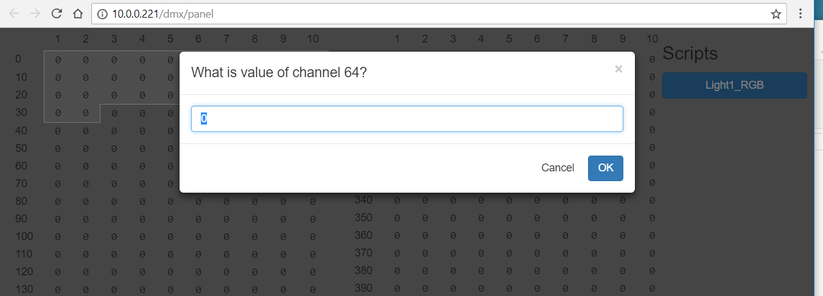

All of your scripts will be listed on the right side of the DMX Control Panel web page. You can click on any of your scripts to execute it. A pop-up box will ask you how many times you want to execute the script.

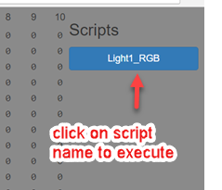

Remote Control to Trigger Scripts

The DMX Control Program can receive the command ‘go script_name’ from one or more clients and the DMX Control Program will immediately execute that script.

Port 10000 is ‘listening’ on the JNIOR to receive the command to execute a script. Multiple connections can be made to this port.

A termination string must be sent by the sending device at the end of the command. The termination string required is \r\n - which is a carriage return (0D), line feed (0A)

Below is an example of a device sending a command to the DMX Control Program that makes the connection to port 10000 and maintains the connection.

The commands that can be sent are:

go script_name (where script_name is the name of the script to execute)
go script_name –r # where ‘r’ means repeat the script # times
go script_name –f where ‘f’ means repeat the script forever
abort script_name stops script_name from running (stops immediately not at end)
abort stops all scripts that are running

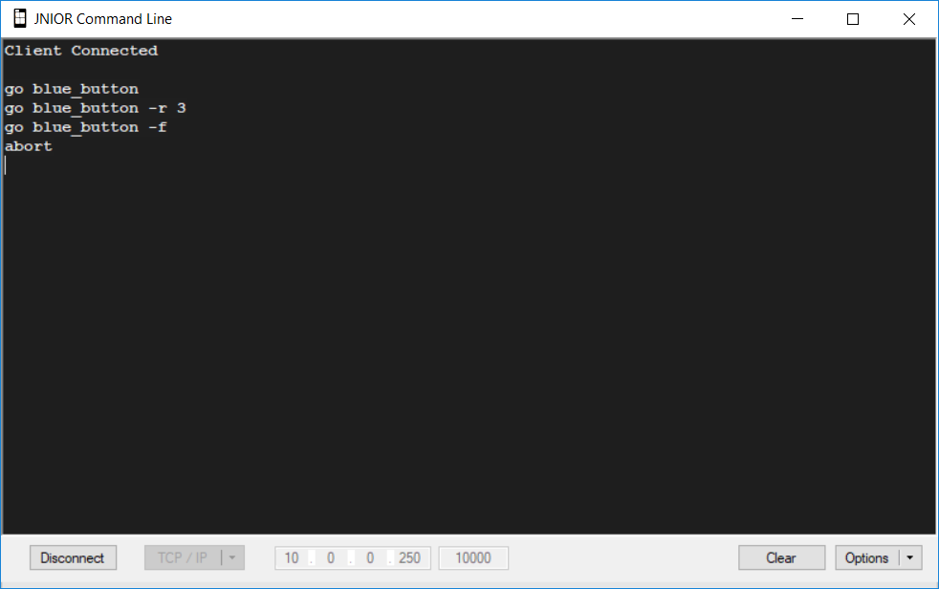

Remote Control via the INTEG Cinema Program

The DMX Control Program can also be controlled from macros utilized by the INTEG Cinema program. The Cinema program can be loaded on the same JNIOR running DMX Control or a different JNIOR or multiple JNIORs because multiple connections can be made to the DMX Control Program.

Please see the INTEG website Support section for additional details on loading and configuring the Cinema program. Below is a summary of how to connect to the DMX Control Program and send the ‘go’ command.

In order to trigger scripts used by the DMX Control Program, the JNIOR running the DMX Control Program must be configured as a Raw Ethernet device as part of the Devices file for the JNIOR running the Cinema program (the same or different JNIOR) as shown below.

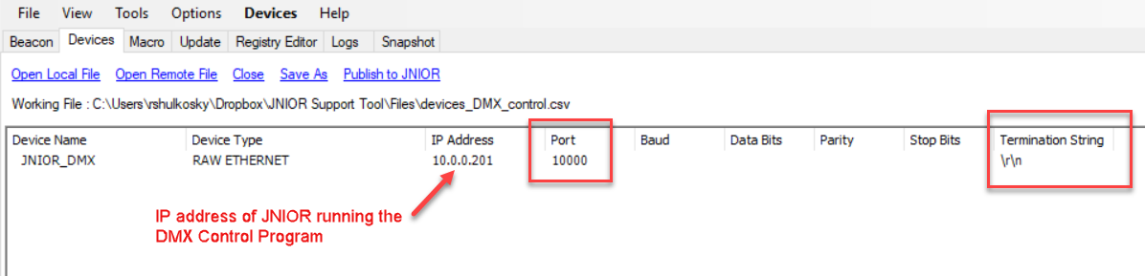

Macros are then created that will send the ‘go’ command to the DMX Control Program as shown below.

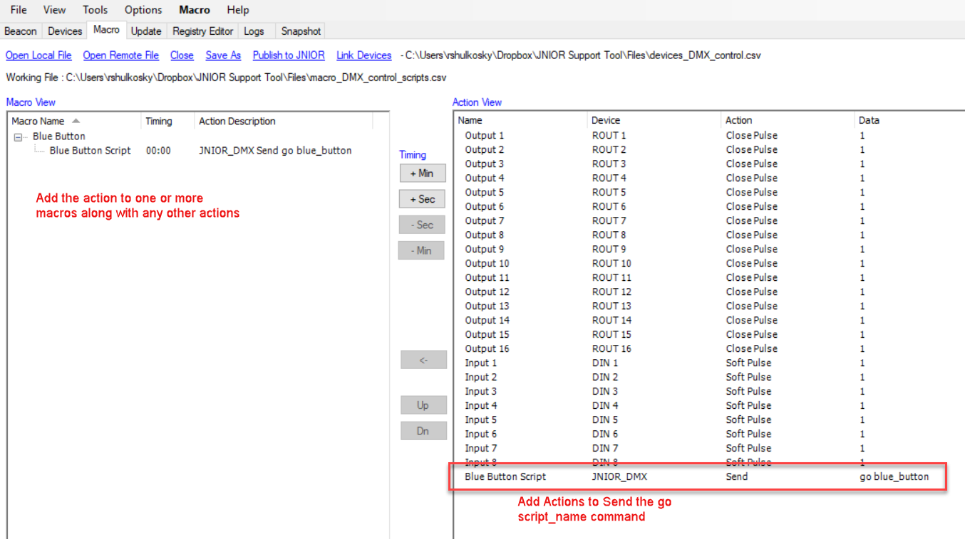

INTEG 3 Channel LED Dimmer Module

The INTEG 3 Channel LED Dimmer module can be configured as a DMX device and controlled by the DMX Control Program. The Dimmer module has three channels to control up to 3 different single color LED strip lights or 1 set of colored (RGB) LED strip lights per Dimmer module. The module can be also be controlled by the INTEG Analog Presets Program.

You can use up to four (4) LED Dimmer modules per JNIOR.

NOTE: The LED Dimmer module and the DMX Control Program ONLY works with the JNIOR Model 412DMX and Model 410.

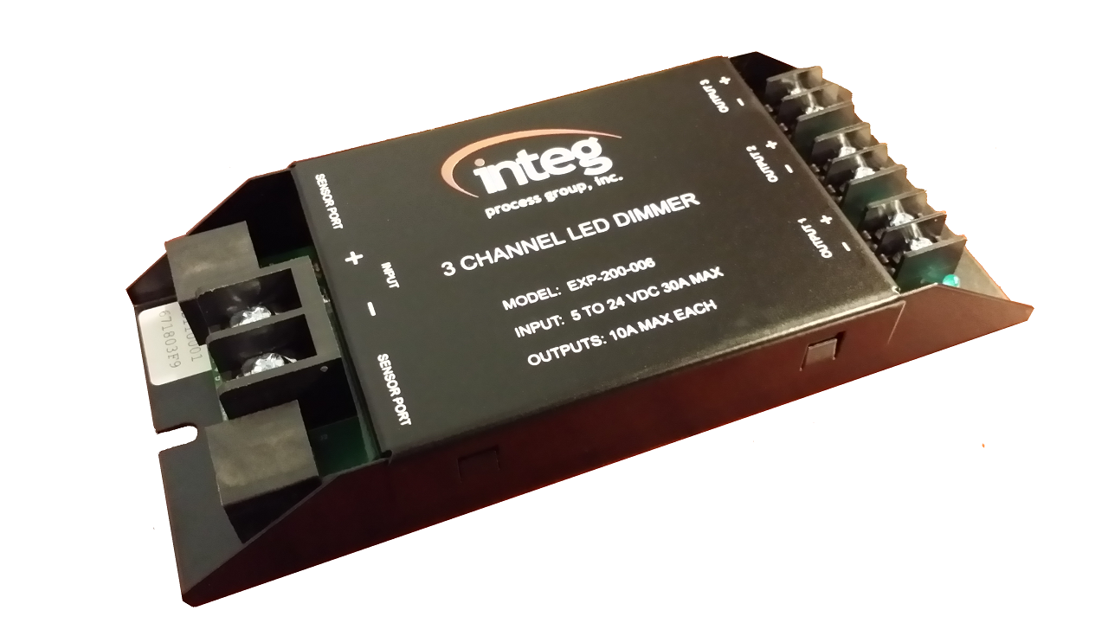

The Dimmer module utilizes six (6) DMX channels per module as follows:

Channel 1 – channel 1 intensity
Channel 2 – channel 2 intensity
Channel 3 – channel 3 intensity
Channel 4 – transition time for changes to channel 1
Channel 5 – transition time for changes to channel 2
Channel 6 – transition time for changes to channel 3

The starting channel is configured via the JNIOR registry. When the DMX Control Program is loaded on a JNIOR with 3 Channel LED Dimmer modules, registry keys will be created under the AppData – DMX registry folder. A registry key is created with the unique ID of each Dimmer Module for the starting DMX channel.

Below is an example of the Dimmer module configuration being done via the Registry tab in the JNIOR Support Tool.

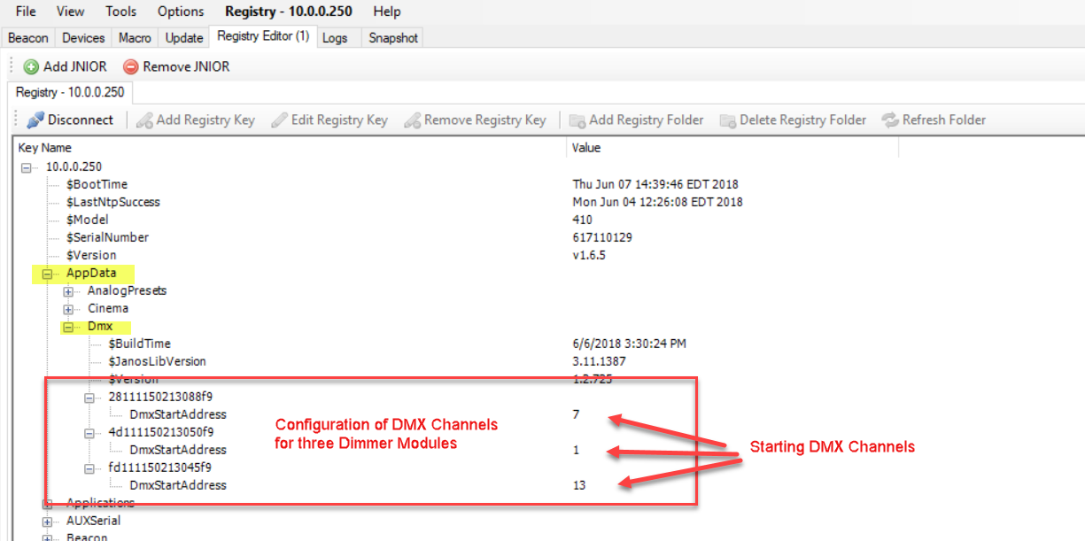

Wiring of the 3 Channel LED Dimmer Module

Each channel can handle up to 10 amps. The expansion module can handle up to 30 amps total.

Each channel uses Pulse Width Modulated (PWM) control to vary the LED strip lighting intensity between 0 and 100%. The voltage is controlled on the negative side to conform with most standard LED strip lights.

NOTE: For white LED strips, connect the + and – wires to the + and – OUTPUT terminals for one of the LED Dimmer channels. For colored LED strips, connect the Red, Green and Blue wires to the – OUTPUT terminals for each of the three LED Dimmer channels. The common wire (fourth wire) coming from the colored LED strip is connected to the + OUTPUT on only one of the LED Dimmer Channels. You do not need to jumper all three of the + OUTPUT connections on the LED Dimmer channels.

A 5 – 24 VDC power supply must be connected to the dimmer module on the + - INPUT terminals to power the LED strip lights. The voltage should match the voltage required by your LED strip lights.

The LED Dimmer expansion module connects to the Sensor port on the JNIOR Series 4 and can be up to 50 feet away from the JNIOR.

Summary

Thank you for purchasing the JNIOR. Hopefully this manual made the getting-to-know process of your new JNIOR very quick and easy. The JNIOR has many more wonderful tools and features available, and are explained in detail in the supplied documents.

Copyright Copyright © 2020 INTEG Process Group, Inc.
All rights reserved.

Notice Every effort was made to make this manual as accurate and useful as practical at the time of the writing of this manual. However, all information is subject to change.

Trademarks Trademarks are the property of their respective holders.
Sun, Sun Microsystems, the Sun logo and Java are trademarks or registered trademarks of Sun Microsystems, Inc. in the United States and other countries.
Microsoft, Windows, MS-DOS and Internet Explorer are registered trademarks of Microsoft Corporation.

Use Restrictions This User’s Manual and the software contained in the JNIOR are copyrighted by INTEG Process group and may not be copied or reproduced without prior consent from INTEG Process Group, Inc. INTEG Process Group is not responsible for any errors or omissions that may be contained in this manual.

Please do not hesitate to contact our JNIOR team at INTEG Process Group, Inc. We can be reached via phone, fax or e-mail as follows:

INTEG Process Group, Inc.
2919 East Hardies Road, First Floor
Gibsonia, PA 15044

www.integpg.com
support@integpg.com

PH (724) 933-9350
FAX (724) 443-3553

