Internet of Things (IoT) – JNIOR MQTT Topic Format

For Use with the JNIOR Series 4

Last updated: December 16, 2020

The following information describes the MQTT Topic format for use with the JNIOR Series 4 and its MQTT communication protocol application.

If you have any questions or want to use the JNIOR and MQTT protocol with additional information available in the JNIOR or with custom information or with a specific broker, please contact INTEG via e-mail at support@integpg.com or via phone at 724-933-9350. INTEG can adapt the MQTT application running on the JNIOR to meet your specific needs.

Overview

The INTEG JNIOR automation controller is capable of being an edge device for the Internet of Things (IoT) applications using the MQTT protocol. The JNIOR can both publish and subscribe to topics using an MQTT broker.

The JNIOR implements the complete MQTT protocol including CONNECT, CONNACK, PUBLISH, PUBACK, SUBSCRIBE, SUBACK and UNSUBSCRIBE. The JNIOR can also provide all three Quality of Service levels.

The JNIOR topics are structured as follows for subscriptions and publications.

Configuration

The MQTT application is loaded on to your JNIOR using an update project provided by INTEG. Please save the update project to your PC and then go to the Update tab in the JNIOR Support Tool and click on Open Project and navigate to where you saved the update project. After the update project is open, click on Publish and then select your JNIOR. The MQTT application will be operational after the update project is completed.

The MQTT application has a web page for some minor configuration items. The web page can be launched by going to the main JNIOR web page and then the Configuration tab and the Applications web page. You will see the MQTT application listed and to the right is an icon. Clicking on the icon will launch the MQTT configuration web page. The JNIOR web page is shown below.

Or you can go to the web page directly by typing your JNIOR IP address/MQTT in your browser. An example is as follows.

http://10.0.0.210/Mqtt

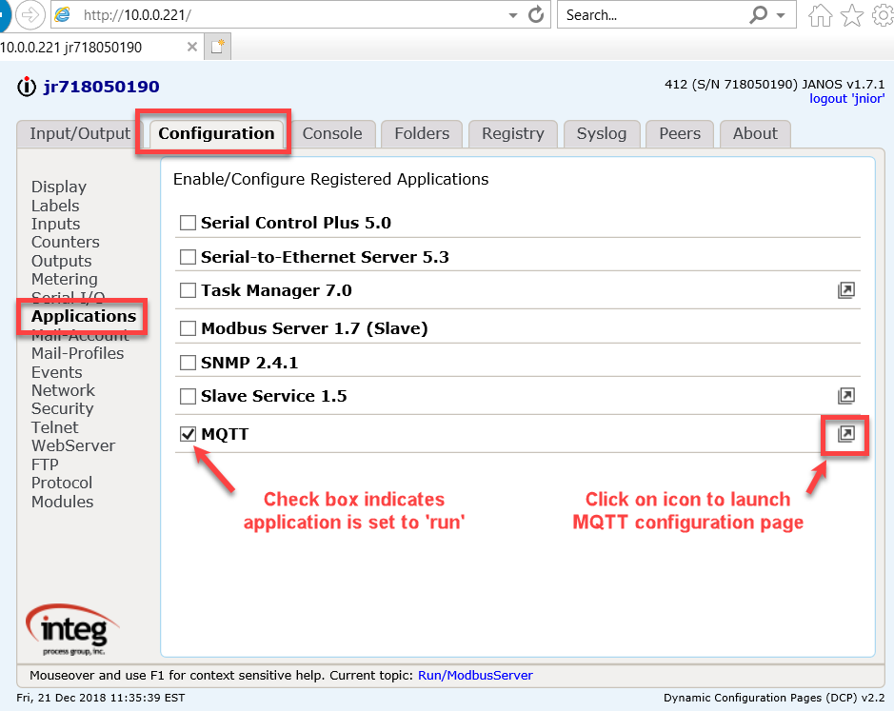

Below is the MQTT web page. The minimum information you need to enter is the MQTT Broker Host. The default MQTT port of 1883 will be used. Click on Save Changes when done. Make sure you have the MQTT application running on your jnior to create a connection. The MQTT application will automatically connect to the MQTT broker and provide feedback that it is connected. It may take a few seconds for the connection to be completed.

NOTE: Depending on which broker you’re using, you might be able to create or are provided a username and password to interact with it. Make sure to enter this into the Username and Password fields in order to connect to that broker.

NOTE: The Device Groups field is for allowing multiple jniors to be called on the same topic name. You simply type a device group you wish to create and then when making a publish or subscription, you type the device group instead of the serial number.

NOTE: The Relay Output Groups is for addressing multiple outputs at once by creating a group fro them. You give the group a name, and then you give it a mask to represent the outputs you wish to trigger when that topic name is in the publish statement.

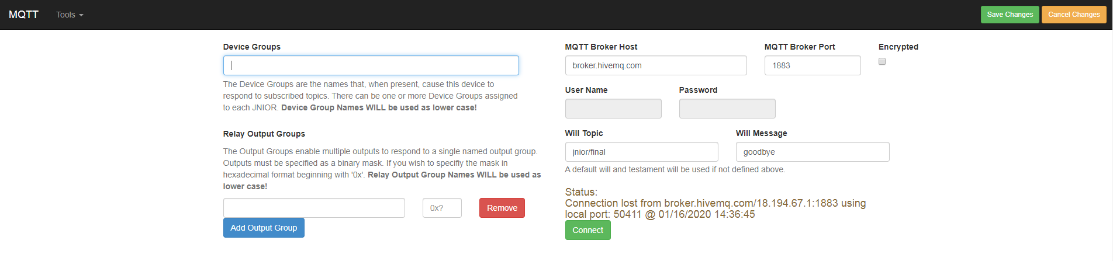

Below is a screen picture indicating the JNIOR has connected to the MQTT Host Broker.

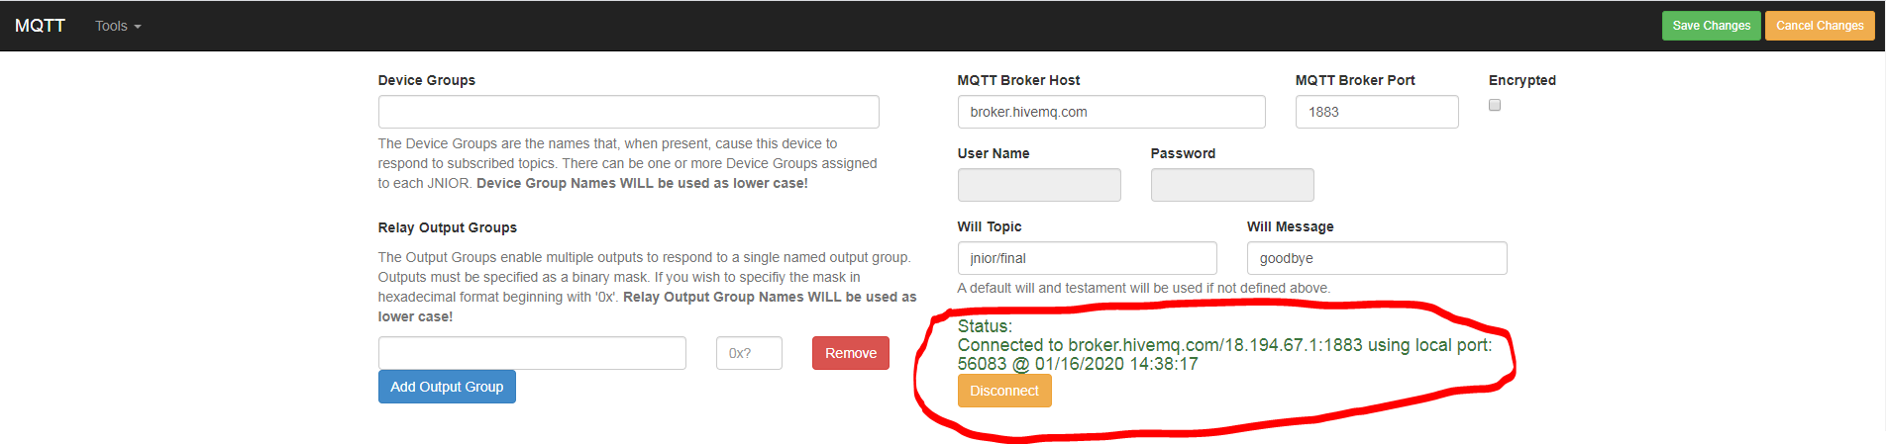

SUBSCRIPTIONS

NOTES:
- Serial_number is replaced with the JNIOR serial number. This makes the data unique per JNIOR.
- The number of digital inputs and outputs is a function of the JNIOR Model being used and any relay output expansion modules attached to the JNIOR.

 |  |  |  |  | DATA
jnior/serial_number/status | /hostname |  |  |  | Hostname for JNIOR
jnior/serial_number/status | /digital | /inputs | /1 |  | Any input number 1 - 12
 |  |  |  | /state  /counter  /usagemeter | -true or false  -increments each time input goes OFF to ON  -number of hours input has been ON
jnior/serial_number/status | /digital | /outputs | /1 |  | Any output number 1 - 16
 |  |  |  | /state  /usagemeter | -true or false  -number of hours input has been ON
jnior/serial_number/status | /fourtwenty | /inputs | /1 |  | Any input number 1 - 8
 |  |  |  | /raw  /scaled | -raw 0 – 65,535  -scaled value
 | /fourtwenty | /outputs | /1 |  | Any output number 1 - 4
 |  |  |  | /raw  /scaled | -raw 0 – 65,535  -scaled value
jnior/serial_number/status | /tenvolt | /inputs | /1 |  | Any input number 1 - 8
 |  |  |  | /raw  /scaled | -raw 0 – 65,535  -scaled value
 | /tenvolt | /outputs | /1 |  | Any output number 1 - 4
 |  |  |  | /raw  /scaled | -raw 0 – 65,535  -scaled value
jnior/serial_number/status |  | /tempprobe | /1 |  | Any number 1 - 10
 |  |  |  | /fahernheit  /celsius | -degrees Fahrenheit  -degrees Celsius
jnior/serial_number/status |  | /humidity | /1 |  | Any number 1 - 4
 |  |  |  | /percent | -percent humidity
jnior/serial_number/status |  | /environ | /1
 |  |  |  | /humidity  /fahernheit  /celsius | -percent humidity  -degrees Fahrenheit  -degrees Celsius

PUBLICATIONS

DIGITAL INPUTS

You cannot currently publish to the JNIOR digital inputs, but if needed, functionality can be added to:

- turn the digital input ‘logically’ ON or OFF by setting the inversion key for an input
- change the value of the usage meter
- change the value of the counter

 |  |  |  |  | DATA
jnior/serial_number | /digital | /outputs | /1 |  | Any output number 1 - 16
 |  |  |  | /set-state | true or false  -Turns output ON or OFF  true_duration  -Pulses output ON for duration  false_duration  -Pulses output OFF for duration
jnior/serial_number | /4-20 | /outputs | /1 |  | Any output number 1 - 4
 |  |  |  | /set-value | -0 – 100.00%
jnior/serial_number | /tenvolt | /outputs | /1 |  | Any output number 1 - 4
 |  |  |  | /set-value | -0-100.00%

A free application to download called mqtt spy is available to publish and subscribe to topics from a broker. The download is here.

You can create a connection to free online brokers to view messages sent and recieved. A list of available ones to find are here.

Below are pictures of the mqtt-spy client showing that you can ‘publish’ the topic to turn JNIOR relay number 2 ON and also ‘subscribe’ to the topic for the status of relay number 2. When you publish to turn relay 2 ON, the relay will turn ON in the JNIOR web page.

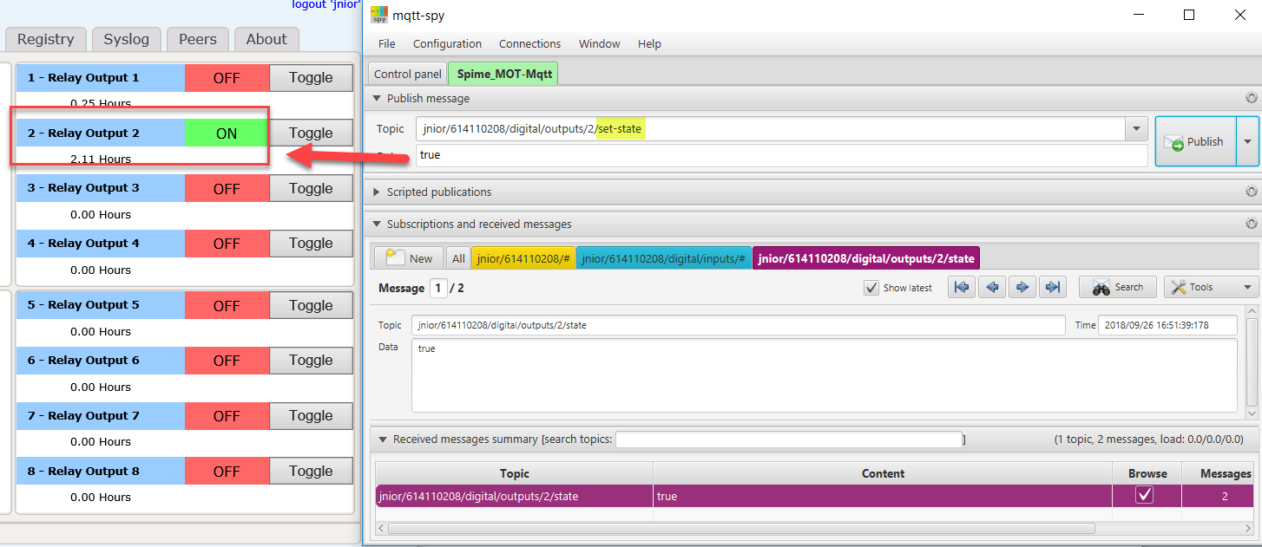

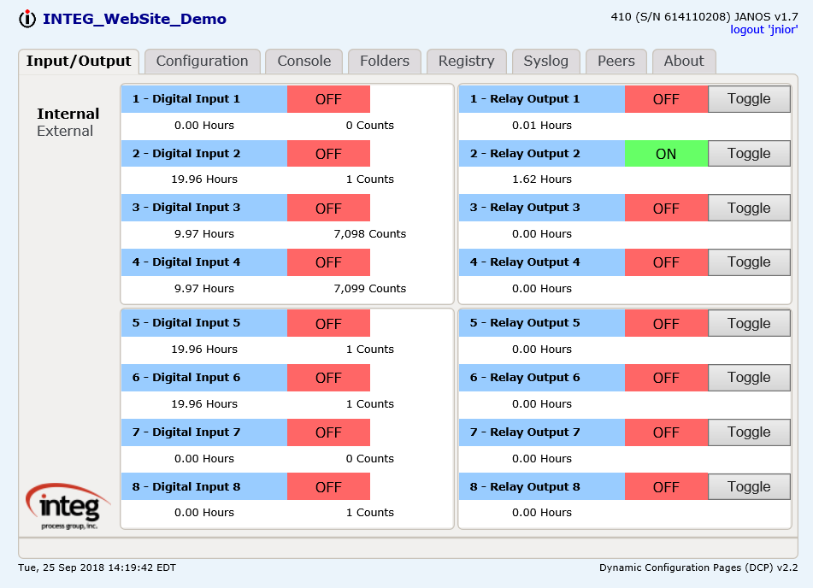

If you elect to subscribe to all of the JNIOR topics and the I/O is changing, then you can see all the data that is changing.

